The Title of Your Presentation
Jane Doe, Biomedical Engineering, University of Rhode Island
BME 281 First Presentation, September 7, 2011 <jane_doe@my.uri.edu>

Abstract—Summarize what this paper is about in less than 50 words. Try to be succinct but self-contained, addressing the “what,” “why,” and “how” questions, if possible.

I. Introduction
THIS document is a template for Microsoft Word versions 6.0 or later. You can also use the free OpenOffice from <www.openoffice.org>. This template is based on the IEEE paper format. You should use this template to prepare your one-page paper. Try to use the standard sections (Introduction, Methods, Results, Discussion, References) if you can. But you can change the section names or not use the section names at all, depending on the nature of the materials that you present. In this section you should provide some background information such as what specific medical problem you are addressing, what is the prevalence of this disease, what are the problems associated with the diagnostic and the treatment, etc.

II. Methods
Present the relevant mathematics, physics, engineering, and technology. Effectively use figures (probably not more than three for the entire paper). Insert the figure in the text where it is mentioned, like this example:
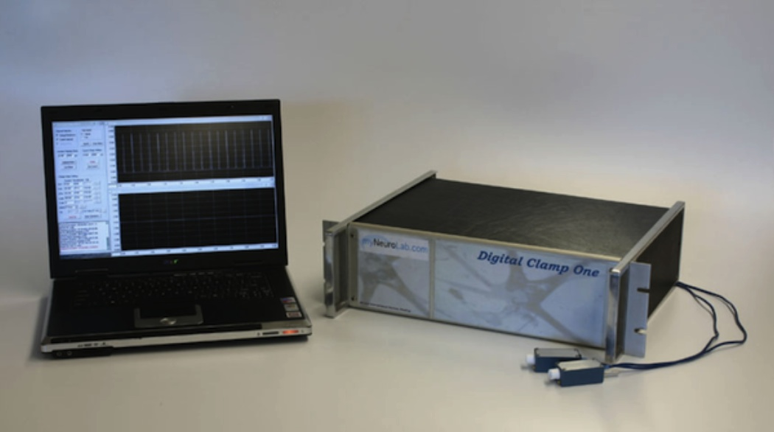
Do not use figure legend in order to save space. The most compatible file format for the figure is JPEG. Reduce the picture resolution (width = 600 pixels should be more than sufficient). Here is another example of an inserted figure.
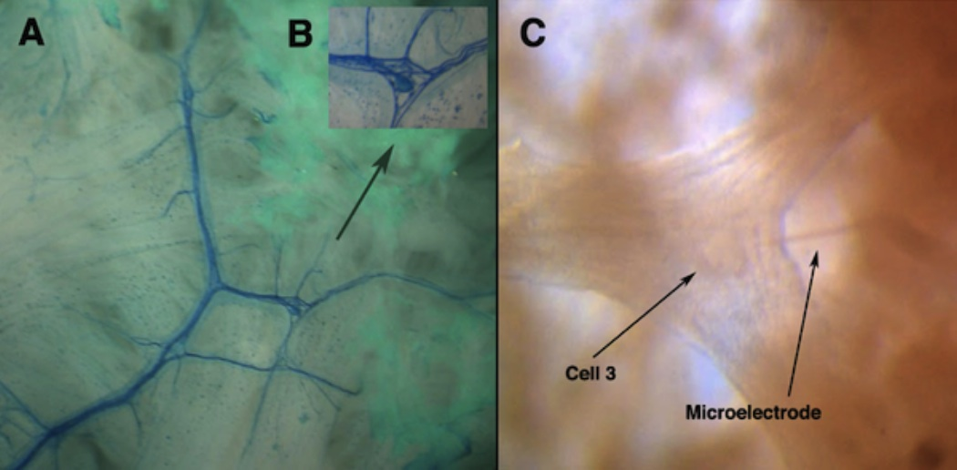
III. Results
For a scientific paper, the results should be presented in this section, which is separated from the methods in the previous section and the discussion in the next section. This section may not be very relevant to your talk if you are doing, for example, a case study on a specific medical device. For a scientific paper this is the section where you would present the data from your research. Effectively use tables and graphs.
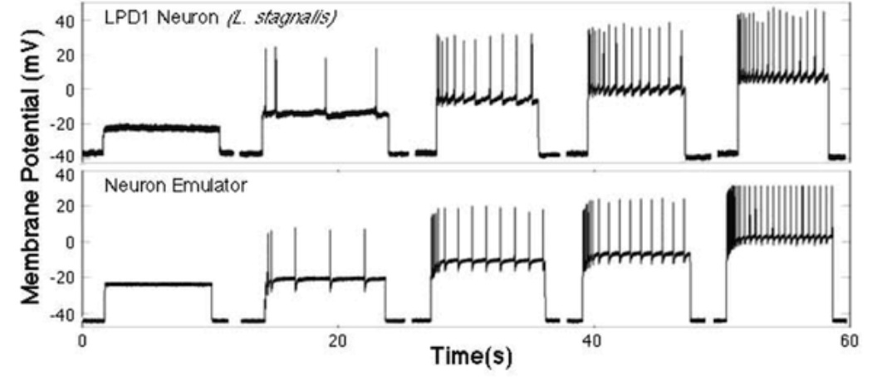
IV. Discussion
This is the section that you provide a conclusion. You could discuss advantages, disadvantages, limitations, design tradeoffs, manufacturability, sustainability, and future directions. You could also discuss economical, social, ethical and global issues relevant to your topic.
The next section, References, is very important. To avoid plagiarism, you need to make sure that the sources of your materials including figures are properly referenced. To save space, you can simply the references by, for example, eliminating the title of the paper and using only the first author’s last name followed by et al. For website references, you normally would need URL and the date it was retrieved. Because you have the presentation date at the top, you don’t need to add the date again. The typical number of references for our seminar presentations is between 3 and 6.
In conclusion, your one-page paper should be succinct but comprehensive, which provides a useful and efficient document on the topic of your choice. Fully utilize the allotted page, but do not go over one page. Please also pay attention to the file size. Even with 3 figures, this file is only 299 KB.

References
- URI BME 281 BME Seminar II <www.ele.uri.edu/courses/bme281>.
- Wikipedia: Biomedical Engineering <en.wikipedia.org/wiki/ Biomedical_engineering>.
- Whitesides GM. Whitesides’ group: write a paper. Advanced Materials 16(15): 1375-7, 2004.
- Blake G, Bly RW. The elements of technical writing. Longman, 1993.
- Wu J, Sun Y, DiCecco J, Hill R. A universal instrument for biological measurements, stimulation, clamping, and processing. 31st Annual Northeast Bioengineering Conference, pp. 25-26, 2005.
- Sun Y, Wu J, Collis L, Hill RB. Apparatus for neuromuscular measurement and control. US Patent No. 7,489,965 B2, 2009.

