ELE 314 Linear Systems and Signals – HomeWork #3 (6%) Ying Sun

Name: Due date:
Circuit Analysis Using Laplace Transform and Fourier Transform: High-Pass Filter
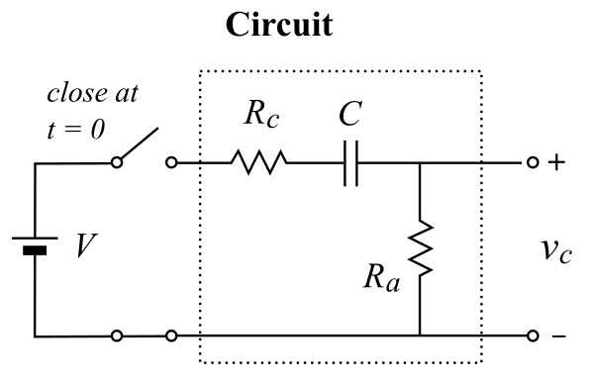
The schematic on the right shows a first-order high-pass filter. A constant voltage (V) is applied to the input of the circuit by closing the switch at t = 0. The output is the voltage across the resistor (Ra). The circuit can be represented as a linear time-invariant (LTI) system. We first normalize the input voltage: V = 1. Thus, the input is the unit step function u(t), and the output is the step response s(t). The LTI system can be completely characterized by its impulse response h(t). The step response is the convolution between the input step function and the impulse response: s(t) = u(t) h(t).

Following the steps of the example for the low-pass circuit. Complete the following.

Homework 3a: Circuit analysis using differential equations (1%)
Obtain the first-order differential equation by evaluating the Kirchhoff's current law at the output node. Solve the differential equation and plot the output (step response) as a function of time.

Homework 3b: Transfer function (1%)
Derive the transform function using the Laplace transforms of the circuit components.

Homework 3c: Impulse response (1%)
Take the inverse Laplace transform of the transfer function to obtain the impulse response. Plot the impulse response as a function of time.

Homework 3d: Fourier transform (1%)
Obtain the Fourier transform H(jω) by substituting $s=jω$ in the transfer function. Obtain the expression of the magnitude and phase of H(jω).

Homework 3e: Frequency response (1%)
Assign values to the circuit components: $R_{a}.=.R_{c}.=.10KΩ$; $C.=.0.1μF$. Use the online graphing calculator at <www.desmos.com/calculator> to plot the magnitude and phase of the frequency response.

Homework 3f: Bode plot (1%)
Fine the locations of the pole and the zero of the system. Use the online Bode plot generator at <http://http://www.onmyphd.com/?p=bode.plot> to generate the Bode plot for the magnitude and the phase.

