ELE 314 Linear Systems and Signals – HomeWork #2 Convolution (4%) Ying Sun

Name: Due date:
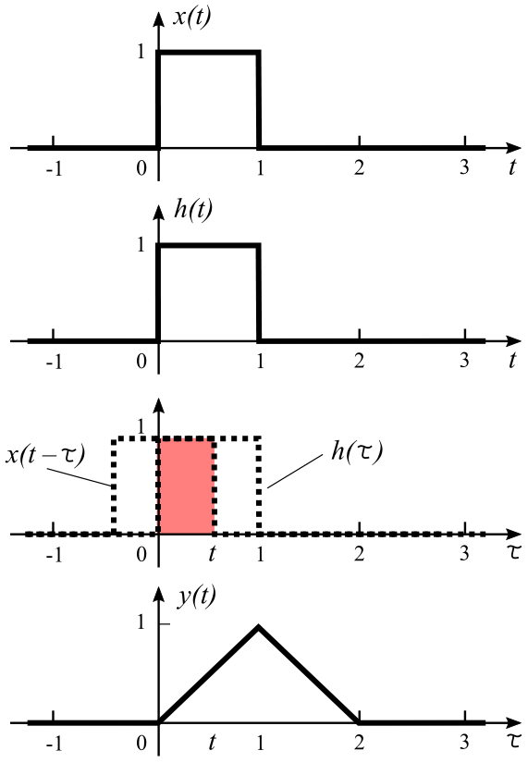
Example 1:
For a LTI system, the impulse response h(t) and input x(t) are $h\left(t\right)=x\left(t\right)=u\left(t\right)−u\left(t−1\right)$. Plot and obtain a mathematical expression for the output y(t).
$y\left(t\right).=.\int_{−∞}^{∞}{x}\left(t−τ\right)h\left(τ\right)dτ.=.$
$\left\{\begin{aligned}0,aaaat<0a \\ \int_{0}^{t}{d}τa0≤t<1 \\ \int_{t−1}^{1}{d}τa1≤t<2 \\ 0,aaaat≥2a\end{aligned}\right..=.\left\{\begin{aligned}0,aaaat<0a \\ {\left[τ\right]}_{0}^{t},a0≤t<1 \\ {\left[τ\right]}_{t−1}^{1},1≤t<2 \\ 0,aaaat≥2a\end{aligned}\right.$
$y\left(t\right).=.\left\{\begin{aligned}0,aaaat<0a \\ t,aaa0≤t<1 \\ 2−t,a1≤t<2 \\ 0,aaaat≥2a\end{aligned}\right.$
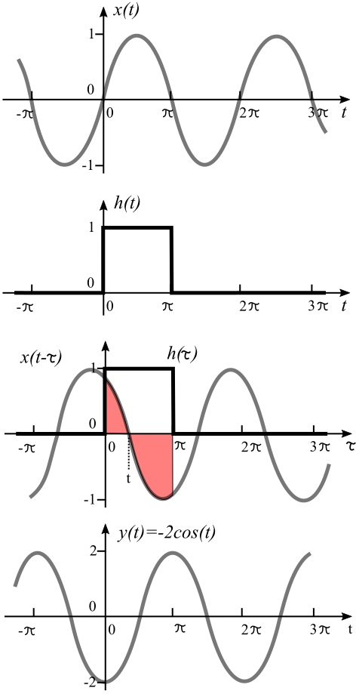
Example 2:
For a LTI system, the impulse response is a square pulse between 0 and π $h\left(t\right)=u\left(t\right)−u\left(t−π\right)$, and the input is a sine wave $x\left(t\right)=sin\left(t\right)$. Plot and obtain a mathematical expression for the output y(t).
y(t) should also be a periodical signal with a period of 2 π.
$y\left(t\right).=.\int_{−∞}^{∞}{x}\left(t−τ\right)h\left(τ\right)dτ.=.$
$\int_{−∞}^{∞}{sin}\left(t−τ\right)\left[u\left(τ\right)−u\left(τ−π\right)\right]dτ.=.$
$\int_{0}^{π}{sin}\left(t−τ\right)dτ.=.{\left[−cos\left(t−τ\right)\left(−1\right)\right]}_{0}^{π}.=.$
$cos\left(t−π\right)−cost.=.−2cost$
Note: from Trigonometry Table:
$cos\left(α−β\right)1=1cosα1cosβ1+1sinα1sinβ$
$cos\left(t−π\right)1=1cost1cosπ1+1sint1sinπ.=.−cost$

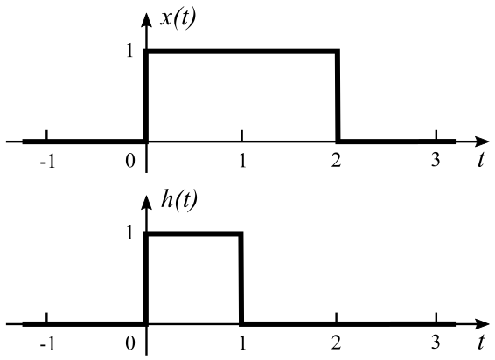
Homework 2a: (1%)
For a LTI system, the impulse response is a square pulse between 0 and 1 $h\left(t\right)=u\left(t\right)−u\left(t−1\right)$. The input x(t) a square pulse between 0 and 2 $x\left(t\right)=u\left(t\right)−u\left(t−2\right)$. Plot and obtain a mathematical expression for the output y(t).

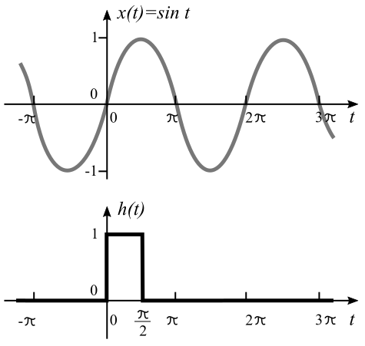
Homework 2b: (1%)
For a LTI system, the impulse response is a square pulse between 0 and π/2 $h\left(t\right)=u\left(t\right)−u\left(t−π/2\right)$, and the input is a sine wave $x\left(t\right)=sin\left(t\right)$. Plot and obtain a mathematical expression for the output y(t).

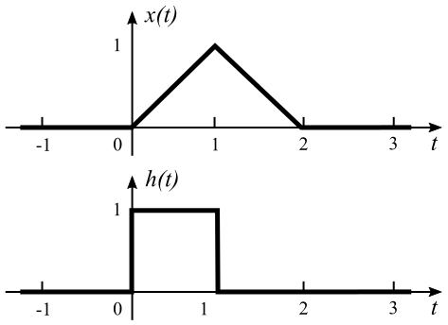
Homework 2c: (2%)
For a LTI system, the impulse response is a square pulse between 0 and 1 $h\left(t\right)=u\left(t\right)−u\left(t−1\right)$. The input x(t) a triangular pulse between 0 and 2, given below. Plot and obtain a mathematical expression for the output y(t).
$x\left(t\right)=\left\{\begin{aligned}0,aaaaaat<0 \\ t,aaa0≤t<1 \\ 2−t,a1≤t<2 \\ 0,aaaaaat≥2\end{aligned}\right.$

