ELE 314 Linear Systems and Signals – HomeWork #4 (6%) Ying Sun

Name: Due date:
Feedback Systems and Digital Filters

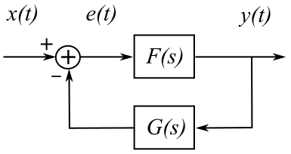
The diagram shows a negative feedback configuration of two LTI systems. The feedforward system F(s) has an impulse response of f(t). The feedback system G(s) has an impulse response of g(t). The error function e(t) is given by:
$e\left(t\right)=x\left(t\right)−g\left(t\right)aaay\left(t\right)$.
The output is given by: $y\left(t\right)=e\left(t\right)aaaf\left(t\right)$.
We have $y\left(t\right)=\left[x\left(t\right)−g\left(t\right)aaay\left(t\right)\right]aaaf\left(t\right)$.
Thus,$y\left(t\right)aa\left[δ\left(t\right)+f\left(t\right)aag\left(t\right)\right].=.x\left(t\right)aaf\left(t\right)$.
Taking LT: $Y\left(s\right)\left(1+F\left(s\right)G\left(s\right)\right).=.X\left(s\right)F\left(s\right).$
The overall transfer function is $H\left(s\right).=.\frac{Y\left(s\right)}{X\left(s\right)}.=.\frac{F\left(s\right)}{1+F\left(s\right)G\left(s\right)}$

Example: Let F(s) be a low-pass filter and G(s) be a high-pass filter. Thus, the low-pass filter is further enhanced by subtracting the high-pass result from the output. The individual transfer functions are given below. Find the overall transfer function, pole-zero plot, Bode plot, and the filter differential equation.
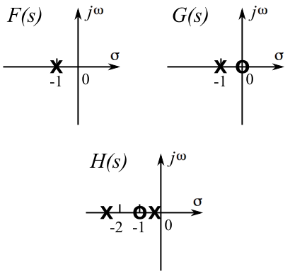
$F\left(s\right).=.\frac{1}{s+1}$; $G\left(s\right).=.\frac{s}{s+1}$.

$H\left(s\right).=.\frac{F\left(s\right)}{1+F\left(s\right)G\left(s\right)}.=.\frac{\frac{1}{s+1}}{1+\left(\frac{1}{s+1}\right)\left(\frac{s}{s+1}\right)}.=.$
$.=.\frac{s+1}{{\left(s+1\right)}^{2}+s}.=.\frac{s+1}{{\left(s+1\right)}^{2}+s}.=.$
$\frac{s+1}{s^{2}+3s+1}.=.\frac{s+1}{\left(s+0.382\right)\left(s+2.618\right)}$.
Note: Solving quadratic equation $s^{2}+3s+1$, the two roots are $s={\left(−3±\sqrt{3^{2}−4}\right)}/2$.
The pole-zero plots of the original systems and the overall system are shown. The poles and zeros of the systems are
Poles: -0.382 and -2.618; Zeros: -1; ∞.
The Bode plot can be obtained at <http://www.onmyphd.com/?p=bode.plot>, as shown on the next page.

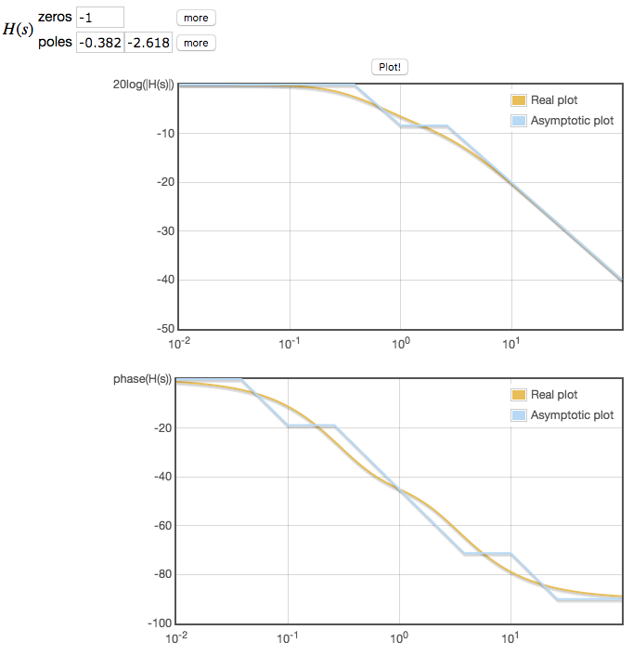
The filter differential equation can be obtained from the transfer function.
$H\left(s\right).=.\frac{s+1}{s^{2}+3s+1}$.
$$Y\left(s\right)\left(s^{2}+3s+1\right).=.X\left(s\right)\left(s+1\right)$$
Take the ILT, we have
$\frac{dy^{2}\left(t\right)}{dt}+3\frac{dy\left(t\right)}{dt}+y\left(t\right).=.\frac{dx\left(t\right)}{dt}+x\left(t\right)$.

Homework 4a: Feedback system (2%)
Example: For the negative feedback system, let F(s) be a high-pass filter and G(s) be a low-pass filter. Thus, the high-pass filter is further enhanced by subtracting the low-pass result from the output. The individual transfer functions are given below. Find the overall transfer function, pole-zero plot, Bode plot, and the filter differential equation.
$F\left(s\right).=.\frac{s}{s+1}$; $G\left(s\right).=.\frac{1}{s+1}$.

Homework 4b: Digital filter – given filter equation (2%)
The filter equation is given by $y\left[n\right].=.\frac{1}{10}\left(x\left[n\right]+4x\left[n−1\right]+4x\left[n−2\right]+x\left[n−3\right]\right)$.
Obtain the impulse response, transfer function, pole-zero plot, magnitude of the FT, and Bode plot.
(Hint: You can use the following website to find the roots of a polynomial:
<http://www.mathportal.org/calculators/polynomials-solvers/polynomial-roots-calculator.php>.)

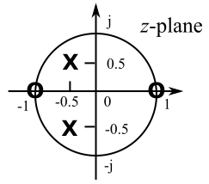
Homework 4c: Digital filter – given pole-zero plot (2%)
For the pole-zero plot shown on the right, what kind of filter is it? Obtain the transfer function, magnitude of the FT (both the equation and the plot), and the filter equation in the time domain.

