ELE 314 Linear Systems and Signals – HomeWork #5 (5%) Ying Sun

Name: Due date:
ZT Properties, Signal Flow Graph, Root Locus Analysis, and State Space Analysis

ZT properties
Geometric Series:
$$a_{0}\sum_{n=0}^{N−1}{r^{n}}.=.a_{0}\frac{1−r^{N}}{1−r}$$
for $r≠0$
Example 1: Show that
$x\left[n\right]=u\left[n\right]$ $⇐z⇒$ $X\left(z\right)=\frac{1}{1−z^{−1}}$
$X\left(z\right).=.\sum_{n=−∞}^{∞}{x}\left[n\right]z^{−n}.=.\sum_{n=−∞}^{∞}{u}\left[n\right]z^{−n}.=.\sum_{n=0}^{∞}{z^{−n}}$
This is a geometric series with a ratio of $z^{−1}$, which converges for $\left|z\right|>1$.
$X\left(z\right).=.\frac{1−z^{−∞}}{1−z^{−1}}.=.\frac{1}{1−z^{−1}}$
Example 2: Prove the Differentiation in z-domain property (#8):
$n.x\left[n\right]$ $⇐z⇒$ $−z\frac{dX\left(z\right)}{dz}$ ROC: $R_{X}$ except at $z=0$
Take the derivative of X(z) with respect to z:
$\frac{dX\left(z\right)}{dz}.=.\frac{d}{dz}\sum_{n=−∞}^{∞}{x}\left[n\right]z^{−n}.=.\sum_{n=−∞}^{∞}{x}\left[n\right]−nz^{−n−1}.=.−z^{−1}\sum_{n=−∞}^{∞}{n}x\left[n\right]z^{−n}$
$−z\frac{dX\left(z\right)}{dz}.=.\sum_{n=−∞}^{∞}{n}x\left[n\right]z^{−n}$
Thus, $n.x\left[n\right]$ $⇐z⇒$ $−z\frac{dX\left(z\right)}{dz}$

Homework 5a: (1%) Prove the Summation in time-domain property (#8):
$\sum_{k=−∞}^{n}{x}\left[k\right]$ $⇐z⇒$ $\frac{1}{1−z^{−1}}X\left(z\right)$ ROC: at least $R_{X}.∩.\{\left|z\right|>1\}$
(Hint: Use the result from Example 1. Arrange the time-domain expression as the convolution between x[n] and u[n].)

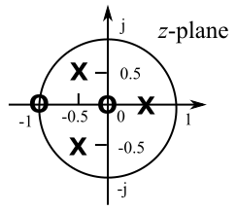
Signal Flow Graph
Example 1: For the pole-zero plot shown on the right, find H(z) and realize the filter with Direct Form II.

$H\left(z\right).=.\frac{\left(z−0\right)\left(z+1\right)}{\left(z−0.5\right)\left(z+0.5+0.5j\right)\left(z+0.5−0.5j\right)}.=.$
$\frac{z^{2}+z}{\left(z−0.5\right)\left(z^{2}+z+0.5\right)}.=.\frac{z^{2}+z}{z^{3}+0.5z^{2}−0.25}.=.\frac{z^{−1}+z^{−2}}{1+0.5z^{−1}−0.25z^{−3}}.=.\frac{z^{−1}+z^{−2}}{1−\left(−0.5z^{−1}+0.25z^{−3}\right)}$,
which fits the form of
$H\left(z\right)=\frac{Y\left(z\right)}{X\left(z\right)}.=.\frac{\sum_{k=0}^{N}{b_{k}}z^{−k}}{1−\sum_{k=1}^{N}{a_{k}}z^{−k}}$, with
$a_{1}=−0.5$ $b_{0}=0$
$a_{2}=0$ $b_{1}=1$
$a_{3}=0.25$ $b_{2}=1$

Thus, the Direct Form 2 realization is as shown.
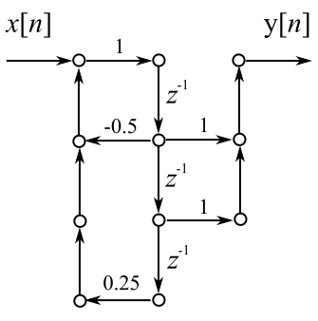
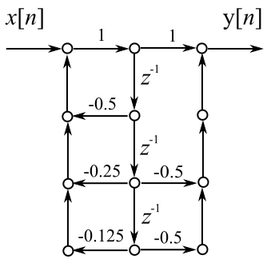
Homework 5b: (1%) What is the filter equation for the Direct Form 2 realization shown on the right?

Root Locus Analysis
Homework 5c: (1%) Plot the root locus for$1+KG\left(s\right)H\left(s\right)=0$, where
the loop gain is given by $G\left(s\right)H\left(s\right)=\frac{s+1}{s^{2}+s+1.25}$.
You can use RootLocs, which is a freeware downloadable from <<http://www.coppice. myzen.co.uk/RootLocs_Site/RootLocs.html>.

State Space Analysis
Homework 5d: (2%) An LTI system is characterized by a second-order differential equation:
$\frac{d^{2}y\left(t\right)}{dt^{2}}+2\frac{dy\left(t\right)}{dt}+y\left(t\right).=.x\left(t\right)$
(i) Find the transfer function H(s) by use of the traditional method.
(ii) Derive the state-space representation.
(iii) Find H(s) by use of the state-space method.

