Circuit Analysis Using Laplace Transform and Fourier Transform: 3-Element RC Circuit
Ying Sun

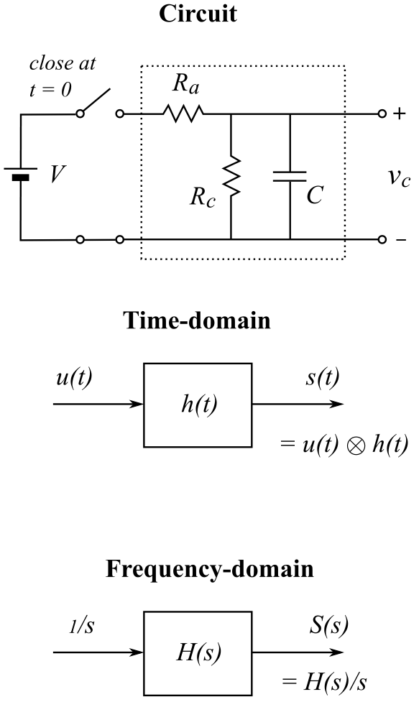
The schematic on the right shows a 3-element RC circuit. A constant voltage (V) is applied to the input of the circuit by closing the switch at t = 0. The output is the voltage across the capacitor (C). The circuit can be represented as a linear time-invariant (LTI) system. We first normalize the input voltage: V = 1. Thus, the input is the unit step function u(t), and the output is the step response s(t). The LTI system can be completely characterized by its impulse response h(t). The step response is the convolution between the input step function and the impulse response: s(t) = u(t) h(t).

In the frequency domain, the transfer function H(s) is the Laplace transform (LT) of the impulse response h(t). The LT of the unit step function is simply s. As convolution in time domain becomes multiplication in frequency domain, the Laplace transform of the step response is the product of s and H(s).

Circuit analysis using differential equations

This is a first-order circuit with only one node, i.e. where the three elements join together. For t ≥ 0, by evaluating Kirchhoff's current law at the node we have:
$\frac{V−v_{c}}{R_{a}}.=.\frac{v_{c}}{R_{c}}1+1C\frac{{dv}_{c}}{dt}$ ------------------- (1)
By rearranging terms, we have:
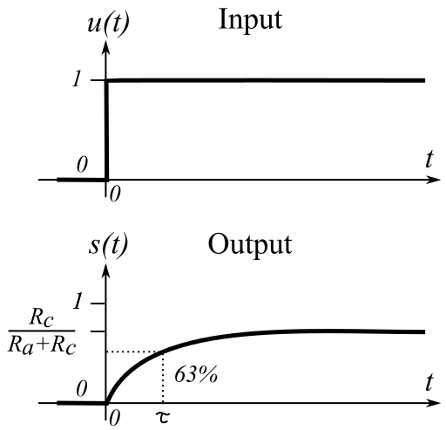
$\frac{{dv}_{c}}{dt}.=.\frac{V}{R_{a}C}.−.\frac{R_{a}+R_{c}}{R_{a}R_{c}C}.v_{c}$ -------------- (2)
Assuming the capacitor is fully discharged at t = 0, the initial condition and the boundary condition, respectively, are:
$v_{c}=0,1t=0$ and $v_{c}={\left(R_{c}V\right)}/{\left(R_{a}+R_{c}\right)},1t=∞$
The solution of the 1st-order differential equation is:
$v_{c}.=.\frac{R_{c}V}{R_{a}+R_{c}}.\left(1−.e^{−\frac{R_{a}+R_{c}}{R_{a}R_{c}C}.t}\right).=.\frac{R_{c}V}{R_{a}+R_{c}}.\left(1−.e^{{−t}/τ}\right)$
------------------------------------------------ (3)
where $τ=R_{a}R_{c}C/{\left(R_{a}+R_{c}\right)}$is the time constant of the circuit.
Circuit analysis using Laplace transform

The transform function is simply the voltage divider in the Laplace domain, where the impedance of the capacitor is 1/ sC :
$H\left(s\right).=.\frac{{R_{c}}/{\left(1+sR_{c}C\right)}}{R_{a}+{R_{c}}/{\left(1+sR_{c}C\right)}}.=.\frac{R_{c}}{R_{a}+R_{c}+sR_{a}R_{c}C}$ --------------------------------------- (4)
The LT of the step response is:
$S\left(s\right).=.H{\left(s\right)}/s.=.\frac{{R_{c}}/{\left(R_{a}+R_{c}\right)}}{s\left(1+sR_{a}R_{c}C/{\left(R_{a}+R_{c}\right)}\right)}$ ---------------------------------------------- (5)
Applying the partial fraction technique and let $R_{ac}=R_{a}{R_{c}}/{\left(R_{a}+R_{c}\right)}$:
$S\left(s\right).=.\frac{A}{s}.+.\frac{B}{1+sR_{ac}C}.=.\frac{A\left(1+sR_{ac}C\right)+sB}{s\left(1+sR_{ac}C\right)}.=.\frac{A+s\left(AR_{ac}C+B\right)}{s\left(1+sR_{ac}C\right)}$ ---------------- (6)
Equating the numerators of eq (5) and (6), we have:
$\frac{R_{c}}{R_{a}+R_{c}}.=.A.+.s\left(AR_{ac}C+B\right)$ ---------------------------------------------------------------- (7)
$A.=.\frac{R_{c}}{R_{a}+R_{c}}$, and $B.=.−AR_{ac}C$ ------------------------------------------------------------ (8)
Solving for B, we have:
$B.=.−\left(\frac{R_{c}}{R_{a}+R_{c}}\right)R_{ac}C$---------------------------------------------------------------------------- (9)
Substituting (8) and (9) into (6), the LT of the step response S(t) is given by:
$S\left(s\right).=.\left(\frac{R_{c}}{R_{a}+R_{c}}\right)\left(\frac{1}{s}.−.\frac{R_{ac}C}{1+sR_{ac}C}\right).=.\left(\frac{R_{c}}{R_{a}+R_{c}}\right)\left(\frac{1}{s}.−.\frac{1}{s−\left({−1}/τ\right)}\right)$ ------------------ (10)
where $τ=\left(R_{a}R_{c}\right)C/{\left(R_{a}+R_{c}\right)}=R_{ac}C$.
From the Table of Laplace Transforms: $\frac{1}{s}.→.u\left(t\right)$ and $\frac{1}{s−a}.→.e^{at}$ ---------------------- (11)
The step response is the inverse LT of (10):
$s\left(t\right).=.\frac{R_{c}}{R_{a}+R_{c}}.\left(1.−.e^{{−t}/τ}\right)$ ------------------------------------------------------------------- (12)
which is the same as (3) with the input voltage V normalized to 1.

Transfer function and impulse response

From (4), the transfer function is:
$H\left(s\right)=\left(\frac{R_{c}}{R_{a}+R_{c}}\right)\frac{1}{1+sR_{a}R_{c}C/{\left(R_{a}+R_{c}\right)}}=\left(\frac{R_{c}}{τ\left(R_{a}+R_{c}\right)}\right)\frac{1}{s−\left({−1}/τ\right)}=\left(\frac{1}{R_{a}C}\right)\frac{1}{s−\left({−1}/τ\right)}$ ---- (13)
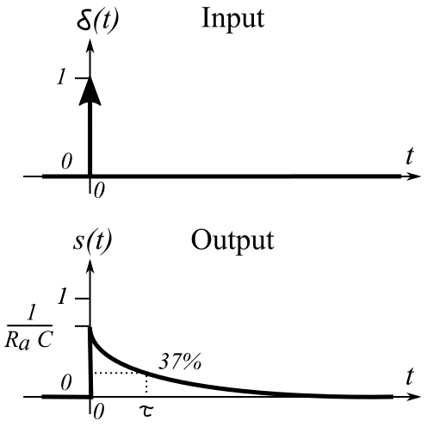
Taking the inverse LT results in the impulse response:
$h\left(t\right).=.\frac{1}{R_{a}C}.e^{{−t}/τ}$ -------------------------------- (14)
which completely characterizes the dynamics of the linear time-invariant system. The time constant τ, given by $R_{a}R_{c}C/{\left(R_{a}+R_{c}\right)}$, is when the output drops to 37% (1/e) of the initial value. Notice that the initial value $1/{R_{a}C}$ is independent of $R_{c}$.

Fourier transform

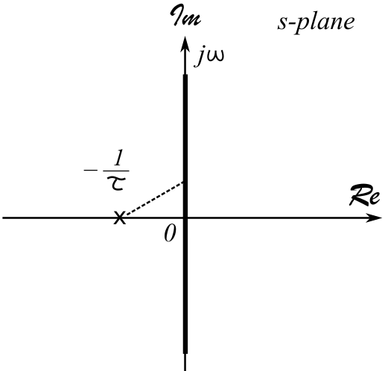
Zeros are points on the s-place where the transfer function H(s) is 0. Poles are points on the s-place where H(s) approaches to ∞. From (13), we see that this first-order system has one zero at s = ∞ and one pole at s = –1/τ. As shown in the figure, the pole is marked by “X”. Because the Fourier transform (FT) is evaluated along the jω axis of the s-plane, the denominator of H(s), $s−\left({−1}/τ\right)$, is represented by the dashed line. As the frequency (ω) increases from 0 (DC) to infinity, the magnitude of the line increases and the magnitude of H(jω) decreases. Thus, the system is a low-pass filter.

The FT is obtained by substituting $s=jω$ in (13), we have:
$H\left(jω\right).=.\left(\frac{1}{R_{a}C}\right)\frac{1}{jω+1/τ}.=.\left(\frac{1}{R_{a}C}\right)\frac{1/τ−jω}{1/{τ^{2}}+ω^{2}}$---- (15)
Taking the magnitude of (15), we have:
$\left|.H\left(jω\right).\right|.=.\left(\frac{1}{R_{a}C}\right)\frac{1}{\sqrt{1/{τ^{2}}+ω^{2}}}$ ----------------------- (16)
The angle is given by:
$∢H\left(jω\right).=.−\tan^{−1}τω$ --------------------------------- (17)

Frequency response

Let's assign values to the circuit components so that we can plot the frequency response as an example. Let's assume:
$R_{a}.=.R_{c}.=.10KΩ$; $C.=.0.1μF$ ---------------------------------------------- (18)
Based on these values, we have:
$\frac{R_{c}}{R_{a}+R_{c}}.=.0.5$; and $τ.=\frac{R_{a}R_{c}C}{R_{a}+R_{c}}.=.0.0005$ ----------------------------------- (19)
Inserting these values into (16), we have:
$\left|.H\left(jω\right).\right|.=.\left(\frac{1}{R_{a}C}\right)\frac{1}{\sqrt{1/{τ^{2}}+ω^{2}}}.=.\frac{1000}{\sqrt{4000000+ω^{2}}}$ --------------------------- (20)
$∢H\left(jω\right).=.−\tan^{−1}0.0005ω$ ------------------------------------------------------ (21)
Using an online graphing calculator at <www.desmos.com/calculator>, the magnitude of the FT can be plotted as shown in the figure. The low-pass filter has a gain (magnitude) of 0.5 at DC, which decreases as frequency increases. The cutoff frequency fc is at $ω_{c}=1/τ=1/{0.0005}$= 2000 radians/s, where the gain decreases to 71% ($1/{\sqrt{2}}$) of the DC gain. This is called the 3 dB point, because $20\log_{10}\left(1/{\sqrt{2}}\right)=−3$dB. The angular frequency is related to the regular frequency by $ω=2πf$. Thus, the cutoff frequency is $f_{c}={ω_{c}}/{2π}=318$Hz. The phase of H(s) given by (21) is also plotted.
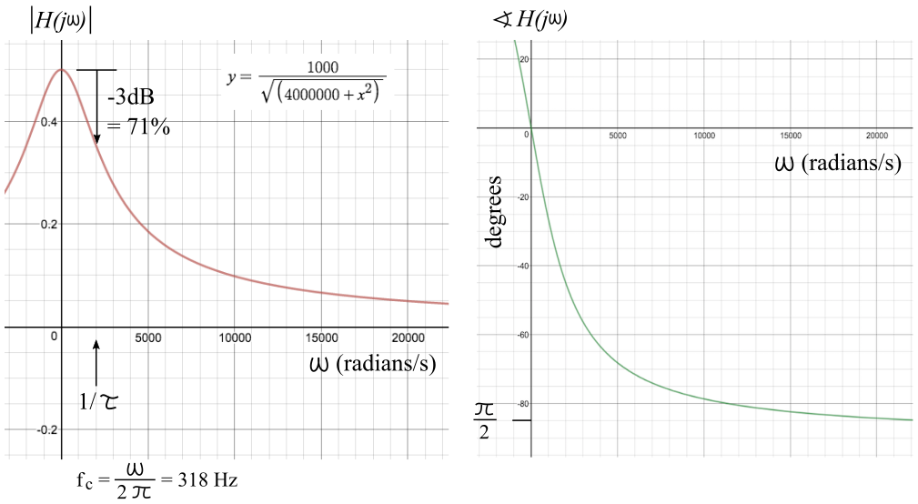
Bode plot

Bode plot is a graph of the frequency response of a system on the log-log scales. The transfer function H(s) in (13) shows one zero at s = ∞ and one pole at s = –1/τ = -2000. Using an online Bode plot generator at <http://www.onmyphd.com/?p=bode.plot>. We obtain the following:

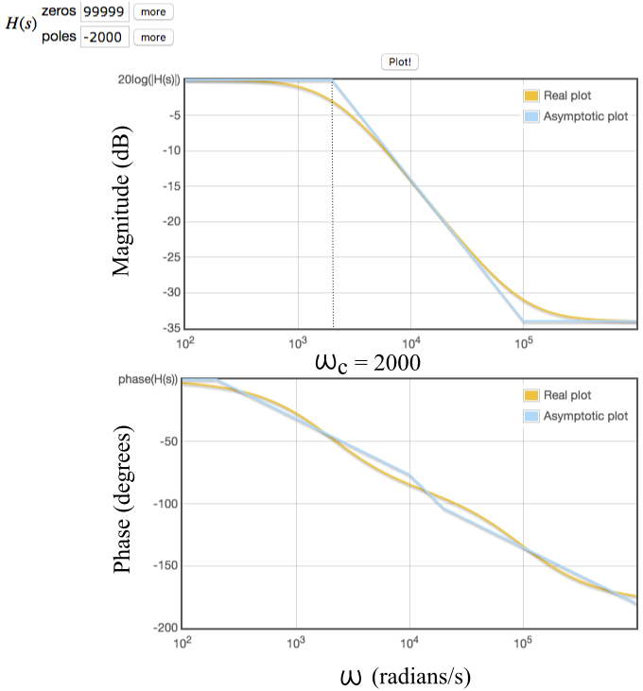
Please note that the above Bode plot assumes that the DC gain is 1 or 0 dB, which should be 0.5 or -6 dB. So the actual magnitude Bode plot should be shifted down by 6 dB. For a first-order low-pass filter, the slope of the declining portion of the Bode plot is -20 dB per decade. For example, the magnitude drops from 0 dB to -20 dB for frequency from 2000 radians/s to 20000 radians/s.

