Circuit Analysis Using Laplace Transform and Fourier Transform: RLC Low-Pass Filter


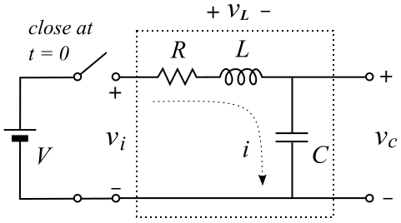
The schematic on the right shows a 2nd-order RLC circuit. A constant voltage (V) is applied to the input of the circuit by closing the switch at t = 0. The output is the voltage across the capacitor (C). The circuit can be represented as a linear time-invariant (LTI) system. The input is$v_{i}$. If a constant voltage is applied at t = 0, it is a step input. We further normalize the input voltage V = 1 such that it's unit step function. Thus, the input is the unit step function u(t), and the output is the step response s(t). The LTI system can be completely characterized by its impulse response h(t). The step response is the convolution between the input step function and the impulse response: s(t) = u(t) h(t).

Circuit analysis using Laplace transform

The circuit analysis can be done by use of the Kirchhoff's voltage law and the properties of capacitor and inductor:
$i.=.C\frac{dv_{c}}{dt}$ , and $v_{L}.=.L\frac{di}{dt}$---------------------------------------------------------------------- (1)
$v_{i}.=.Ri+v_{L}+v_{c}.=.Ri+L\frac{di}{dt}+v_{c}$ -------------------------------------------------------------- (2)
By substituting (1) into (2), we have:
$v_{i}.=.LC\frac{d^{2}v_{c}}{dt^{2}}+RC\frac{dv_{c}}{dt}+v_{c}$ --------------------------------------------------------------------- (3)
Although a closed form solution can be obtained by solving the above 2nd-order differential equation, we will take the frequency-domain approach. Taking LT on both side, we have:
$V_{i}\left(s\right).=.LCs^{2}V_{c}\left(s\right)+RCsV_{c}\left(s\right)+V_{c}\left(s\right)$ ------------------------------------------------------ (4)
The transfer function is given by:
$H\left(s\right).=.\frac{V_{c}\left(s\right)}{V_{i}\left(s\right)}.=.\frac{1}{LCs^{2}+RCs+1}$ ------------------------------------------------------------- (5)
We now use a different set of parameters:
$H\left(s\right).=.\frac{ω_{n}^{2}}{s^{2}+2αs+ω_{n}^{2}}$ ---------------------------------------------------------------------------- (6)
where $ω_{n}.=.\frac{1}{\sqrt{LC}}$, natural frequency
$α.=.\frac{R}{2L}$, damping factor
We further define damped frequency $ω_{d}$:
$ω_{d}.=.\sqrt{ω_{n}^{2}−α^{2}}$; or $ω_{n}^{2}.=.ω_{d}^{2}+α^{2}$; or $ω_{n}.=.\sqrt{ω_{d}^{2}+α^{2}}$
To obtain the impulse response, the transfer function is further extended to:
$H\left(s\right).=.\frac{ω_{n}^{2}}{s^{2}+2αs+ω_{n}^{2}}.=.\frac{ω_{n}^{2}}{\left(s+α+\sqrt{α^{2}−ω_{n}^{2}}\right)\left(s+α−\sqrt{α^{2}−ω_{n}^{2}}\right)}.=.\frac{ω_{n}^{2}}{\left(s+α+jω_{d}\right)\left(s+α−jω_{d}\right)}.=.$
$\frac{ω_{d}^{2}+α^{2}}{s^{2}+2αs+α^{2}+ω_{d}^{2}}.=.\left(ω_{d}+\frac{α^{2}}{ω_{d}}\right)\left(\frac{ω_{d}}{{\left(s+α\right)}^{2}+ω_{d}^{2}}\right)$ ----------------------------------------------- (7)
The system has two poles at: $−α+jω_{d}$and $−α−jω_{d}$.
Taking the ILT, the impulse response is:
$h\left(t\right).=.\left(ω_{d}+\frac{α^{2}}{ω_{d}}\right)e^{−αt}sinω_{d}t$ -------------------------------------------------------------------- (8)
Next, we want to get a closed form solution for the step response. This will be accomplished by extending H(s) to H(s)/s, or S(s), which is the LT of the step response.
$S\left(s\right).=.\frac{H\left(s\right)}{s}.=.\left(ω_{d}+\frac{α^{2}}{ω_{d}}\right)\left(\frac{1}{s}\right)\left(\frac{ω_{d}}{{\left(s+α\right)}^{2}+ω_{d}^{2}}\right).=.\frac{a}{s}+\frac{bs+c}{{\left(s+α\right)}^{2}+ω_{d}^{2}}$
$ω_{d}^{2}+α^{2}.=.a{\left(s+α\right)}^{2}+aω_{d}^{2}+bs^{2}+cs.=.\left(a+b\right)s^{2}+\left(2aα+c\right)s+a\left(ω_{d}^{2}+α^{2}\right)$
We have $a+b=0$, $2aα+c=0$, and $ω_{d}^{2}+α^{2}=a\left(ω_{d}^{2}+α^{2}\right)$⇒ a = 1, b = -1, and c = -2α.
$S\left(s\right).=.\frac{1}{s}−\frac{s+2α}{{\left(s+α\right)}^{2}+ω_{d}^{2}}.=.\frac{1}{s}−\frac{s+α}{{\left(s+α\right)}^{2}+ω_{d}^{2}}−\left(\frac{α}{ω}\right)\frac{ω_{d}}{{\left(s+α\right)}^{2}+ω_{d}^{2}}$ ------------------------- (9)
Using the LT Table, we obtain the step response s(t):
$s\left(t\right).=.1−e^{−αt}\left[cosω_{d}t+\left(\frac{α}{ω_{d}}\right)sinω_{d}t\right]$ ------------------------------------------------------- (10)
Next, we want to combine cosine and sine into one term with a phase angle. We further define the damping ratio η, $η=\frac{α}{ω_{n}}$.
$\frac{α}{ω_{d}}.=.\frac{α}{\sqrt{ω_{n}^{2}−α^{2}}}.=.\frac{1}{\sqrt{{ω_{n}^{2}}/{α^{2}}−1}}.=.\frac{1}{\sqrt{1/{η^{2}}−1}}.=.\frac{η}{\sqrt{1−η^{2}}}$ --------------------------------- (11)
$s\left(t\right).=.1−e^{−αt}\left[cosω_{d}t+\left(\frac{η}{\sqrt{1−η^{2}}}\right)sinω_{d}t\right].=.1−\frac{e^{−αt}}{\sqrt{1−η^{2}}}\left[\sqrt{1−η^{2}}cosω_{d}t+ηsinω_{d}t\right].=.$
$1−\frac{e^{−αt}}{\sqrt{1−η^{2}}}\left[sinϕcosω_{d}t+cosϕsinω_{d}t\right].=.1−\frac{e^{−αt}}{\sqrt{1−η^{2}}}sin\left(ω_{d}t+ϕ\right)$ --------------------- (12)
where $tanϕ.=.\frac{sinϕ}{cosϕ}.=.\frac{\sqrt{1−η^{2}}}{η}$, $ϕ.=.\tan^{−1}\frac{\sqrt{1−η^{2}}}{η}$.
From the previous circuit course, such as ELE 212, you might have learned what the damping ratio means: a) underdamping$\left(η<1\right)$; b) critical damping $\left(η=1\right)$; and c) overdamping $\left(η>1\right)$.
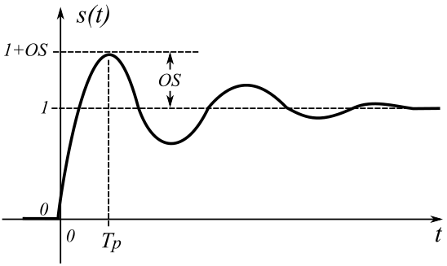
Assume the underdamping situation, s(t) is shown on the right. The 2nd-order system requires two parameters to define, such as the damped frequency$ω_{d}$and the damping factor$α$. These two parameters can be obtained from the s(t) curve by making two measurements. A prominent feature point is the first peak after the onset. We measure the time to peak$T_{p}$ and the amount of overshoot (OS). This point occurs when the derivative of the curve is 0.
$\frac{ds\left(t\right)}{dt}.=.0$
$\frac{ds\left(t\right)}{dt}.=.h\left(t\right).=.\left(ω_{d}+\frac{α^{2}}{ω_{d}}\right)e^{−αt}sinω_{d}t.=.0$. ------------------------------------------------ (13)
The peaks and valleys occur when $ω_{d}t$ = 0, π, 2π, 3 π, 4π, …. The first peak occurs when $ω_{d}t=π$.
Thus, $T_{p}=\frac{π}{ω_{d}}$, or $ω_{d}=\frac{π}{T_{p}}$ ------------------------------------------------------------------------- (14)
At the first peak $T_{p}$,
$s\left(T_{p}\right).=.1−\frac{e^{−αT_{p}}}{\sqrt{1−η^{2}}}sin\left(ω_{d}T_{p}+\tan^{−1}\frac{\sqrt{1−η^{2}}}{η}\right).=.1−\frac{e^{−αT_{p}}}{\sqrt{1−η^{2}}}sin\left(π+\tan^{−1}\frac{\sqrt{1−η^{2}}}{η}\right).=.$
$1+\frac{e^{−αT_{p}}}{\sqrt{1−η^{2}}}sin\left(\tan^{−1}\frac{\sqrt{1−η^{2}}}{η}\right).=.1+\frac{e^{−αT_{p}}}{\sqrt{1−η^{2}}}\sqrt{1−η^{2}}.=.1+e^{−αT_{p}}.=.1+OS$. ------------ (15)
Thus, $e^{−αT_{p}}.=.OS$, or $α.=.−\frac{lnOS}{T_{p}}$. ------------------------------------------------------------- (16)

Frequency response

Let's assign values to the circuit components so that we can plot the frequency response as an example. Let's assume:
$R.=.40Ω$; $L.=.1.mH$; $C.=.0.1μF$ ------------------------------------------------- (17)
Based on these values, we have:
$ω_{n}.=.\frac{1}{\sqrt{LC}}.=.\frac{1}{\sqrt{1mH×0.1μF}}.=.100000$radians/s; and
$α.=.\frac{R}{2L}.=.\frac{40Ω}{2×1mH}.=.20000$
$ω_{d}.=.\sqrt{ω_{n}^{2}−α^{2}}.=.\sqrt{{100000}^{2}−{20000}^{2}}.=.97980$radians/s.
$η.=.\frac{α}{ω_{n}}.=.\frac{20000}{100000}.=.0.2$; $ϕ.=.\tan^{−1}\frac{\sqrt{1−η^{2}}}{η}.=.\tan^{−1}\frac{\sqrt{1−0.2}}{0.2}.=.1.35$radians.
The transfer function is $H\left(s\right).=.\left(ω_{d}+\frac{α^{2}}{ω_{d}}\right)\left(\frac{ω_{d}}{{\left(s+α\right)}^{2}+ω_{d}^{2}}\right)$. The system has the poles at $−α±jω_{d}$ , or $−20000±97980j$. The zeros are at infinity.

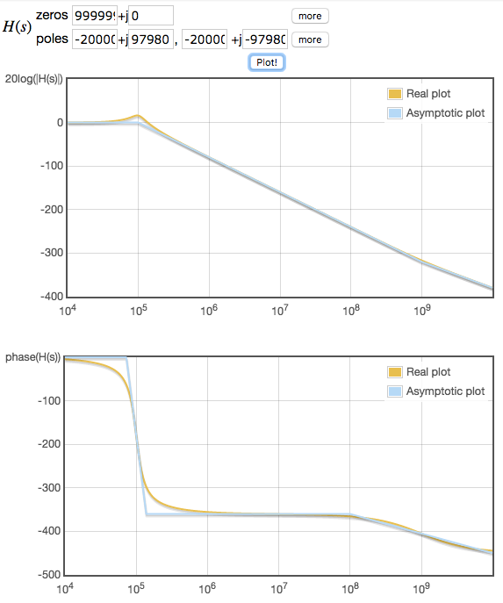
Bode plot

Enter the poles of$−20000±97980j$ at the online Bode plot generator <http://http://www.onmyphd.com/?p=bode.plot>. We obtain the following:

Step response
$$s\left(t\right).=.1−\frac{e^{−αt}}{\sqrt{1−η^{2}}}sin\left(ω_{d}t+ϕ\right).=.$$
$$1−\frac{e^{−20000t}}{0.9798}sin\left(97980t+1.35\right).=.$$
Due to a range issue with the graphing calculator, we change the time unit from s to ms:
$$s\left(t\right).=.1−\frac{e^{−20t}}{0.9798}sin\left(97.98t+1.35\right)$$
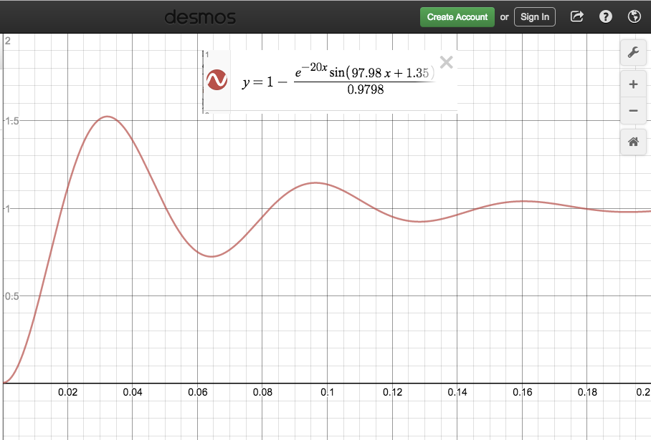
From the graph, we see that the peak occurs roughly at: $T_{p}=0.0323$ms, and OS = 0.52.
Using the formula derived previously:
$ω_{d}.=.\frac{π}{T_{p}}.=.\frac{3.14159}{0.0000323}.=.97263$,
as compare to $ω_{d}.=.97980$.
$α.=.−\frac{lnOS}{T_{p}}.=.−\frac{ln0.52}{0.0000323}.=.20245$,
as compare to $α.=.20000$.

