From Pole-Zero Plot to Differential Equation and Vice Versa
Ying Sun

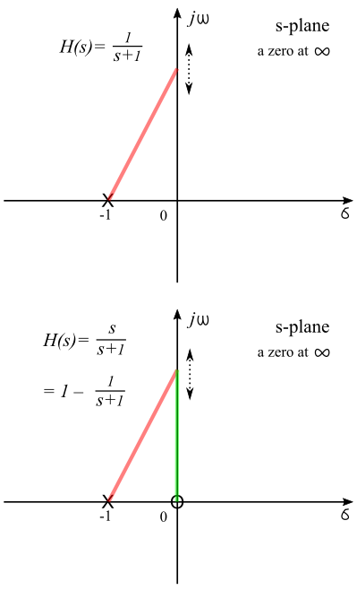
From Pole-Zero Plot to Differential Equation
Previous we learn that $h\left(t\right)=e^{−t}$ is the impulse response of a low-pass filter. The transfer function is $H\left(s\right)=1/{\left(s+1\right)}$. It is a first-order system that has a pole at -1 and a zero at ∞, as shown in the figure (top). The red line is the vector from jω to the pole. The length of this vector increases with the frequency. Thus, it is a low-pass filter because the gain decreases with increasing frequency. We can make this a high-pass filter by moving the zero from infinity to zero such that the gain at DC is zero, as shown in the figure (bottom). The green line is the vector from jω to the zero. The gain approaches unity for high frequency because as ω approaches ∞, the length of the green line and the length of the red line become the same. The complete analysis of this first-order high-pass filter is as follows.

Pole-zero plot: As shown: pole = -1; zero = 0.

Transfer function: $H\left(s\right).=.\frac{s}{s+1}.=.\frac{s−0}{s+1}.=.1−\frac{1}{s+1}$
(rational, factored, partial-fraction forms)

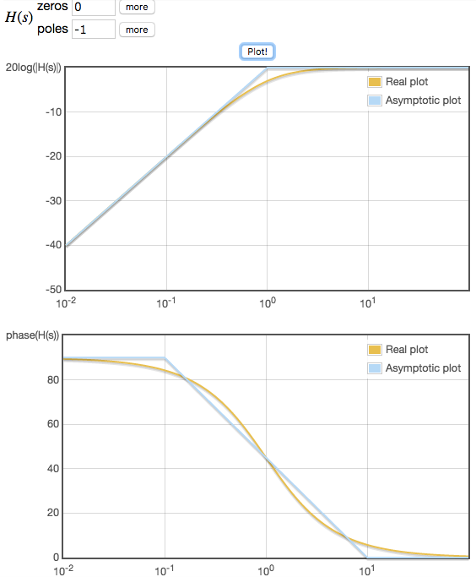
Fourier transform: $H\left(jω\right).=.1−\frac{1}{jω+1}.=.1−\frac{1−jω}{1+ω^{2}}$

Bode plot: <http://www.onmyphd.com/?p=bode.plot>

Impulse response: $h\left(t\right).=.=.δ\left(t\right)−e^{−1}$
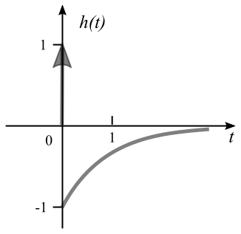

Differential equation:
$H\left(s\right)=\frac{Y\left(s\right)}{X\left(s\right)}=\frac{s}{s+1}$
( rational form)
$sY\left(s\right)+Y\left(s\right)=sX\left(s\right)a→a$

$\frac{dy\left(t\right)}{dt}+y\left(t\right)=\frac{dx\left(t\right)}{dt}a→ay\left(t\right)+\frac{dy\left(t\right)}{dt}−\frac{dx\left(t\right)}{dt}=0$

From Differential Equation to Pole-Zero Plot
The input-output relationship of a LTI system is characterized by the following differential equation:
$$\frac{d^{3}y\left(t\right)}{{dt}^{3}}+4\frac{d^{2}y\left(t\right)}{{dt}^{2}}+6\frac{dy\left(t\right)}{dt}+4y\left(t\right)=\frac{d^{2}x\left(t\right)}{{dt}^{2}}+2\frac{dx\left(t\right)}{dt}+1$$
Transfer function:
$Y\left(s\right)\left(s^{3}+4s^{2}+6s+4\right)=X\left(s\right)\left(s^{2}+2s+1\right)$
$H\left(s\right)=\frac{Y\left(s\right)}{X\left(s\right)}.=.\frac{s^{2}+2s+1}{s^{3}+4s^{2}+6s+4}$ (rational form)
Using <http://www.mathportal.org/calculators/polynomials-solvers/polynomial-roots-calculator.php>:
$H\left(s\right).=.\frac{{\left(s+1\right)}^{2}}{\left(s+1−j\right)\left(s+1+j\right)\left(s+2\right)}$ (factored form)
To obtain the partial-fraction form, we let:
$$\frac{s^{2}+2s+1}{\left(s+1−j\right)\left(s+1+j\right)\left(s+2\right)}.=.\frac{as+b}{s^{2}+2s+2}+\frac{c}{s+2}.=.\frac{\left(as+b\right)\left(s+2\right)+c\left(s^{2}+2s+2\right)}{\left(s+1−j\right)\left(s+1+j\right)\left(s+2\right)}$$

$$s^{2}+2s+1.=.{as}^{2}+\left(2a+b\right)s+2b+{cs}^{2}+2cs+2c.=.\left(a+c\right)s^{2}+\left(2a+b+2c\right)s+2\left(b+c\right)$$

Solving $a+c=1$; $2a+b+2c=2$; and $2\left(b+c\right)=1$, we have $a=c=0.5$and $b=0$.
$H\left(s\right).=.\frac{0.5s}{s^{2}+2s+2}+\frac{0.5}{s+2}$ (partial-fraction form)
As an alternative, the following online partial-fraction calculator can be used:
<http://www.wolframalpha.com/widgets/view.jsp?id=ec4a062bb304f88c2ba0b631d7acabbc>
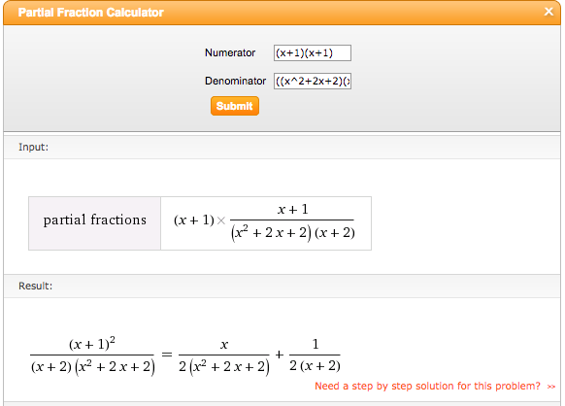
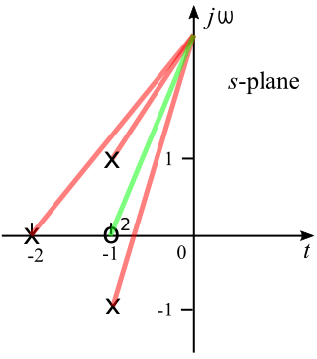
Fourier transfer function:
$H\left(jω\right).=.\frac{{\left(jω\right)}^{2}+2jω+1}{{\left(jω\right)}^{3}+4{\left(jω\right)}^{2}+6jω+4}$
(This needs further simplification.)
Pole-zero plot:
From the factored form of H(s):
$$H\left(s\right).=.\frac{{\left(s+1\right)}^{2}}{\left(s+1−j\right)\left(s+1+j\right)\left(s+2\right)}$$
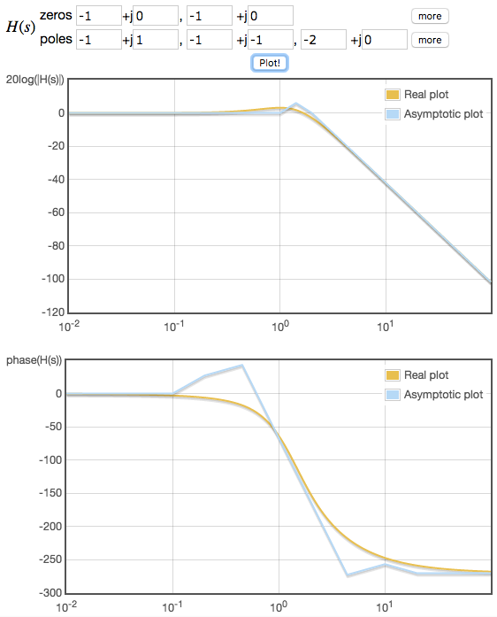
This is a 3rd-order system, which has 3 poles and 3 zeros.
Poles: -1+j, -1-j, and -2;
Zeros: -1, -1, and ∞.
Bode plot:
Bode plot can be generated by entering the poles and zeros into the following website:
<http://www.onmyphd.com/?p=bode.plot>

Impulse response:
From the partial-fraction form of H(s):
$H\left(s\right).=.\frac{0.5s}{s^{2}+2s+2}+\frac{0.5}{s+2}$
First evaluate ILT of $s/{\left(s^{2}+2s+2\right)}$
$\frac{s}{s^{2}+2s+2}.=.\frac{s+1}{{\left(s+1\right)}^{2}+1}−\frac{1}{{\left(s+1\right)}^{2}+1}$
We need the following from the LT Table:
$e^{at}←→\frac{1}{s−a}$; $δ\left(t−c\right)←→e^{−cs}$;
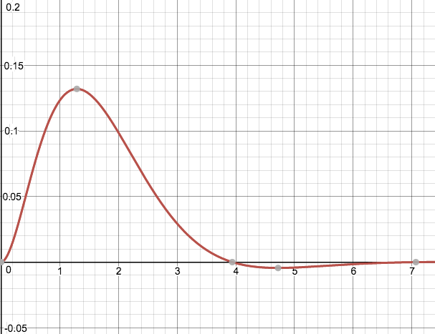
$sinat←→\frac{a}{s^{2}+a^{2}}$; $cosat←→\frac{s}{s^{2}+a^{2}}$.
We have the ILT as follows:
$h\left(t\right).=.\left(0.5e^{−t}\left(sint−cost\right)+0.5e^{−2}t\right)u\left(t\right)$.
The impulse response is plotted using
an online graphing calculator at
<https://www.desmos.com/calculator>

Flowchart of the Analytical Tools for Continuous-Time Systems

