Feedback Implementation


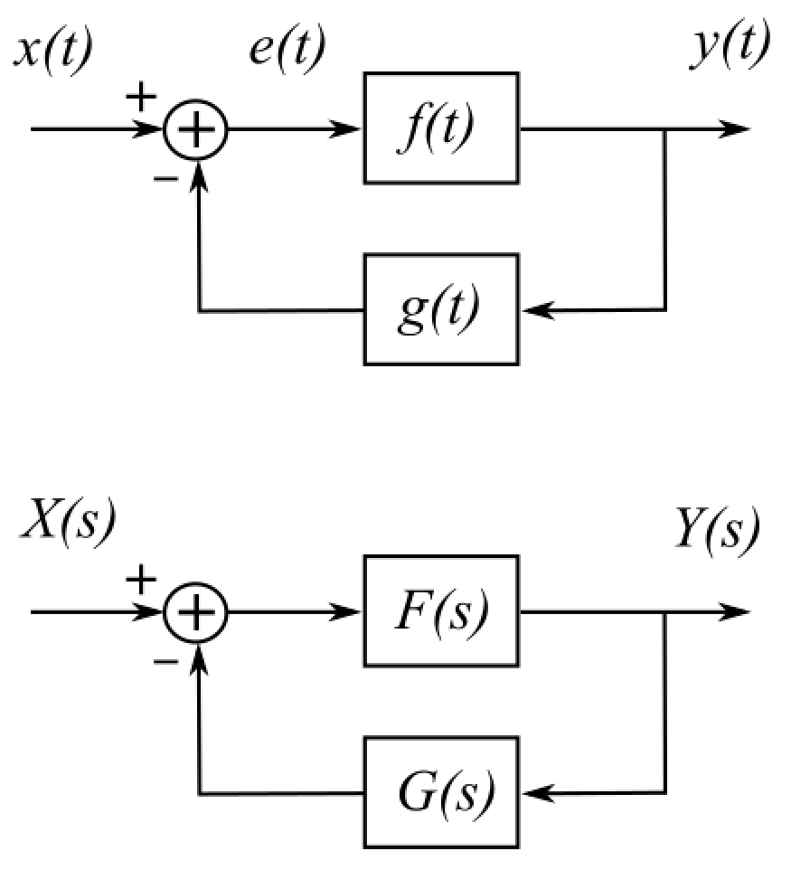
LTI System Implemented with a Feedback Connection
The system shown on the right has a feedforward unit f(t)
and a feedback unit g(t). What is it's overall transfer function H(s)?

The output of the feedback unit is $y\left(t\right)aaag\left(t\right)$.

The error function e(t) is given by

$e\left(t\right).=.x\left(t\right).−.y\left(t\right)aaag\left(t\right)$

The output of the allover system is

$y\left(t\right).=.\left[x\left(t\right).−.y\left(t\right)aaag\left(t\right)\right]aaaf\left(t\right)$

$$y\left(t\right).=.x\left(t\right)aaaf\left(t\right).−.y\left(t\right)aaag\left(t\right)aaaf\left(t\right)$$

$$y\left(t\right).+.y\left(t\right)aaag\left(t\right)aaaf\left(t\right).=.x\left(t\right)aaaf\left(t\right)$$

$$\left[δ\left(t\right).+.g\left(t\right)aaaf\left(t\right)\right]aaay\left(t\right).=.x\left(t\right)aaaf\left(t\right)$$

Take LT on both sides

$\left[1.+.G\left(s\right)F\left(s\right)\right]Y\left(s\right).=.X\left(s\right)F\left(s\right)$

The transfer function is given by

$H\left(s\right).=.\frac{Y\left(s\right)}{X\left(s\right)}.=.\frac{F\left(S\right)}{1.+.G\left(s\right)F\left(s\right)}$

