Digital Filters
Ying Sun

Digital filters

Finite impulse response (FIR) filter: h[n] has a finite numbers of terms.
Infinite impulse response (IIR) filter: h[n] has infinite numbers of terms.

Causal filter: $h\left[n\right]=0$, for all n < 0.
Noncausal filter: $h\left[n\right]≠0$, for at least one n < 0.

Stability

$\sum_{n=−∞}^{∞}{h}\left[n\right]<∞$⇒ stable
FIR filters are always stable. IIR filters may or may not be stable.

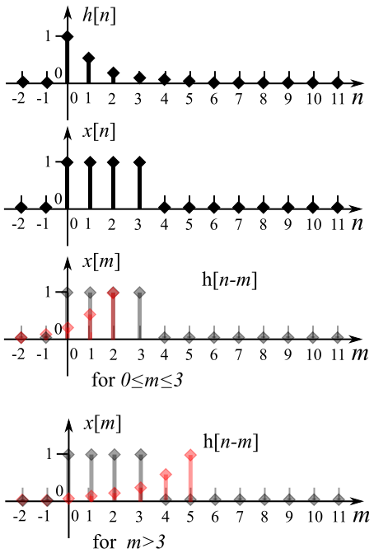
Evaluating filter output by convolution

$y\left[n\right]=\sum_{m=−∞}^{∞}{x}\left[n−m\right]h\left[m\right].=.\sum_{m=−∞}^{∞}{x}\left[m\right]h\left[n−m\right]$
Example 1. The impulse response of a filter
is $h\left[n\right]=e^{−n}u\left[n\right]$. The input is a square pulse:
$x\left[n\right]=\left\{\begin{aligned}1,aan=0,1,2,3 \\ 0,aaaotherwise\end{aligned}\right.$. Determine y[n].
$$y\left[n\right].=.\sum_{m=−∞}^{∞}{x}\left[m\right]h\left[m−n\right].=.$$
$$\left\{\begin{aligned}0,aaaaaaaaaan<0 \\ \sum_{m=0}^{n}{e^{−\left(n−m\right)}},aa0≤n≤3 \\ \sum_{m=0}^{3}{e^{−\left(n−m\right)}},aaaan>3\end{aligned}\right..=.$$
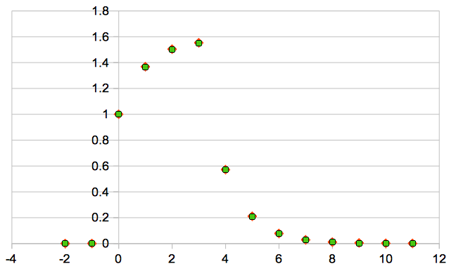
$$\left\{\begin{aligned}0,aaaaaaaaaaaaaaaaaaaaaaaaan<0 \\ 1,aaaaaaaaaaaaaaaaaaaaaaaaan=0 \\ 1+e^{−1},aaaaaaaaaaaaaaaaaaaaan>1 \\ 1+e^{−1}+e^{−2},aaaaaaaaaaaaqqaaan=2 \\ 1+e^{−1}+e^{−2}+e^{−3},aaaaaaaaaaaaan=3 \\ e^{−n}+e^{−\left(n−1\right)}+e^{−\left(n−2\right)}+e^{−\left(n−3\right)},aaan>3\end{aligned}\right.$$
This is a low-pass filter. For the square pulse input, the output is a charge-discharge curve that shows reduction of the high-frequency contents.
Example 2. We implement a 3-point FIR low-pass filter to smooth the data according to:
$y\left[n\right]=\frac{1}{4}\left(x\left[n\right]+2x\left[n−1\right]+x\left[n−2\right]\right)$
If the sampling rate is 200 Hz, what is the cutoff frequency (3 dB roll-off) of this filter?

The impulse response as shown in figure is obtained by setting $x\left[n\right]=δ\left[n\right]$.
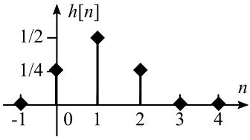
$$h\left[n\right]=\frac{1}{4}\left(δ\left[n\right]+2δ\left[n−1\right]+δ\left[n−2\right]\right)$$
Take z-transform (ZT) of the filter equation above:
$Y\left[z\right]=\frac{1}{4}\left[X\left(z\right)+2z^{−1}X\left(z\right)+z^{−2}X\left(z\right)\right]$.
The transfer function is given by
$H\left[z\right].=.\frac{Y\left(z\right)}{X\left(z\right)}.=.\frac{1}{4}\left[1+2z^{−1}+z^{−2}\right].=.\frac{z^{−1}}{2}\left(\frac{z+2+z^{−1}}{2}\right).=.\frac{z^{−1}}{2}\left(1+\frac{z+z^{−1}}{2}\right)$
The Fourier transform (FT) is the ZT evaluated on the unit circuit of the z-plane .
By replacing $z=e^{jω}$, we have
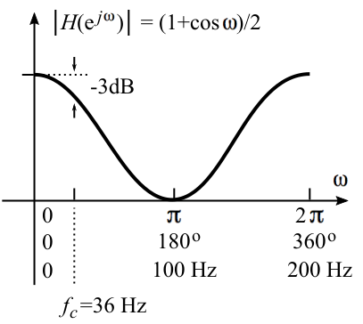
$H\left(e^{jω}\right).=.\frac{e^{−jω}}{2}\left(1+\frac{e^{jω}+e^{−jω}}{2}\right)$
Using the Euler's formula $cosω=\frac{e^{jω}+e^{−jω}}{2}$, we have
$H\left(e^{jω}\right).=.\frac{e^{−jω}}{2}\left(1+cosω\right)$.
The magnitude and phase of $H\left(e^{jω}\right)$are:
$\left|H\left(e^{jω}\right)\right|.=.\frac{1}{2}\left(1+cosω\right)$
$∢H\left(e^{jω}\right).=.−ω$
The system has a linear phase response, which represents a group phase delay. The linear phase is desirable because it does not introduce any phase distortion.
The DC gain of the filter is 1; $\left|H\left(e^{j0}\right)\right|={\left(1+cos\text{\%}0\right)}/2=1$. The cutoff frequency $f_{c}$ is where the gain drops to $1/{\sqrt{2}}$ of the DC gain.
$1/{\sqrt{2}}.=.0.70794...$; $20\log_{10}0.70794.=.−3$dB.
Let $\left|H\left(e^{jω_{c}}\right)\right|.=.\frac{1}{2}\left(1+cosω_{c}\right).=.\frac{1}{\sqrt{2}}$, we have
$$cosω_{c}.=.\sqrt{2}−1.=.1.414−1.=.0.414$$
$ω_{c}.=.\cos^{−1}0.414.=.1.114$ radians/s = ${65.5}^{o}$/s.
The sampling rate is 200 Hz, which corresponds to $2π$ or ${360}^{o}$. The cutoff frequency is:
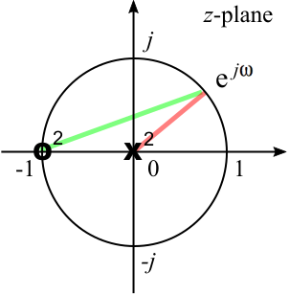
$f_{c}.=.{200×{65.5}^{o}}/{{360}^{o}}.=.36$Hz.
Pole-zero plot: $H\left[z\right].=.\frac{z^{2}+2z+1}{4z^{2}}.=.\frac{{\left(z+1\right)}^{2}}{4z^{2}}$. There are two zeros at -1 and two poles at the origin on the z-plane. The red line shows the vector from $e^{jω}$ to the pole. The green line shows the vector from $e^{jω}$ to the pole. The magnitude of $H\left(e^{jω}\right)$is proportional to the green line squared over the red line squared, as ω goes from 0 to π.

Digital filters implemented with a microprocessor
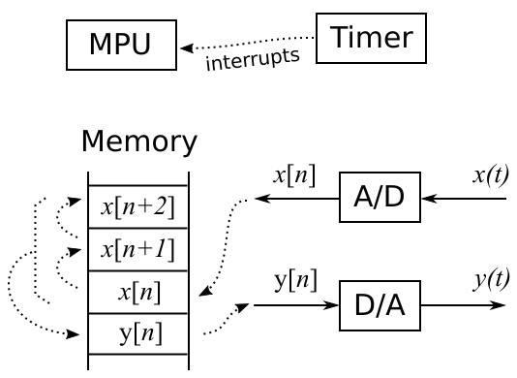
Digital filters can be implemented in real time by using a microprocessor system as shown. In order to sample the data with a precise sampling interval, a timer is used to generate periodical interrupts. The interrupts are processed by the microprocessor unit (MPU). A running buffer is set up in the memory to store the present and previous input sample points. The filter should be implemented in the interrupt service routine with the following pseudocode:

x2 = x1;
x1 = x0;
x0 = read from A/D;
y0 = (x0 + x1 + x1 + x2) / 4;
write y0 to D/A;

Example 3. In the continuous time, the derivative is defined as $\frac{dx\left(t\right)}{dt}=\lim_{Δt→0}{\frac{x\left(t\right)−x\left(t−Δt\right)}{Δt}}$. In the
discrete time, it is not possible to make $Δt→0$. The smallest $Δt$is the sampling period T. Thus, the backward difference is a discrete-time approximation of the derivative. Without losing generality, we let T = 1 and add a scale factor of 1/2.
$y\left[n\right]=\frac{x\left[n\right]−x\left[n−1\right]}{2}$
Plot $\left|H\left(e^{jω_{c}}\right)\right|$ and show the pole-zero plot.
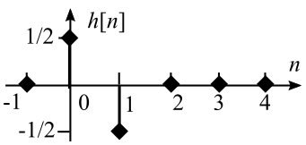
The impulse response is:
$$h\left[n\right]=\frac{δ\left[n\right]−δ\left[n−1\right]}{2}$$
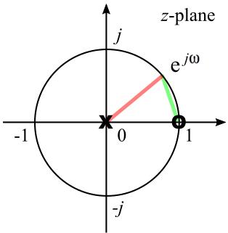
The transfer function is obtained by taking the ZT of h[n].
$$H\left[z\right].=.\frac{1−z^{−1}}{2}.=.\frac{z−1}{2\left(z−0\right)}.=.z^{−\frac{1}{2}}\left(\frac{z^{\frac{1}{2}}−z^{−\frac{1}{2}}}{2}\right)$$
The first-order system has one zero at 1 and one pole at the origin, as shown. To obtain the FT, let $z=e^{jω}$. We have
$H\left(e^{jω}\right).=.e^{\frac{−jω}{2}}\left(\frac{e^{\frac{jω}{2}}−e^{\frac{−jω}{2}}}{2}\right).=.je^{\frac{−jω}{2}}\left(\frac{e^{\frac{jω}{2}}−e^{\frac{−jω}{2}}}{2j}\right)$
Using the Euler's formula $sinω=\frac{e^{jω}−e^{−jω}}{2j}$, we have
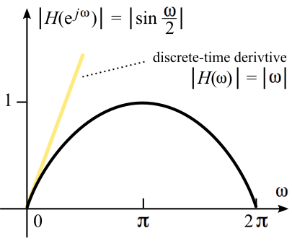
$H\left(e^{jω}\right).=.je^{\frac{−jω}{2}}\left(sin\frac{ω}{2}\right).=.e^{\frac{−jω}{2}}e^{\frac{jπ}{2}}\left(sin\frac{ω}{2}\right).=.e^{\frac{−j\left(ω−π\right)}{2}}\left(sin\frac{ω}{2}\right)$.
The magnitude and phase of $H\left(e^{jω}\right)$are:
$\left|H\left(e^{jω}\right)\right|.=.\left|sin\frac{ω}{2}\right|$
$$∢H\left(e^{jω}\right).=.−\frac{ω−π}{2}$$
Notice that for the continuous time, the LT of the derivative is s and the magnitude of the FT is $\left|H\left(ω\right)\right|.=.ω$, as shown by the orange line. ω and sin(ω/2) are close for low frequencies,, but deviate more for higher frequencies.

Example 4. A low-pass filter can be implemented by averaging the present input with the previous output. The result is an IIR filter. Show the filter equation, impulse response, transfer function, pole-zero plot, an magnitude of the FT. If the sampling rate is 200 Hz, what is the 3-dB cutoff frequency.

The filter equation is $y\left[n\right]=\frac{x\left[n\right]+y\left[n−1\right]}{2}$. This equation is a recursion and can be expanded as follows: $y\left[n\right].=.\frac{1}{2}\left(x\left[n\right]+y\left[n−1\right]\right).=.\frac{1}{2}\left(x\left[n\right]+\frac{1}{2}\left(x\left[n−1\right]+y\left[n−2\right]\right)\right).=.$
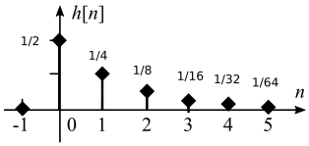
$\frac{1}{2}\left(x\left[n\right]+\frac{1}{2}\left(x\left[n−1\right]+y\left[n−2\right]\right)\right).=.$.
$$\frac{1}{2}x\left[n\right]+\frac{1}{4}x\left[n−1\right]+\frac{1}{4}\left(x\left[n−2\right]+y\left[n−3\right]\right)$$
The impulse response has infinite number of terms:
$$h\left[n\right].=.\frac{1}{2}δ\left[n\right]+\frac{1}{4}δ\left[n−1\right]+\frac{1}{8}δ\left[n−2\right]+...$$
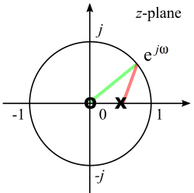
Take ZT of the filter equation: $Y\left(z\right)=\frac{X\left(z\right)+z^{−1}Y\left(z\right)}{2}$. We have
$H\left(z\right).=.\frac{Y\left(z\right)}{X\left(z\right)}.=.\frac{1}{2−z^{−1}}.=.\frac{z−0}{2\left(z−\frac{1}{2}\right)}$. The first-oder system has ones zero at the origin and one pole at 1/2, as shown.
The FT is obtained by replacing $z=e^{jω}$:
$H\left(e^{jω}\right).=.\frac{1}{\left(2−cosω\right)+jsinω}$.
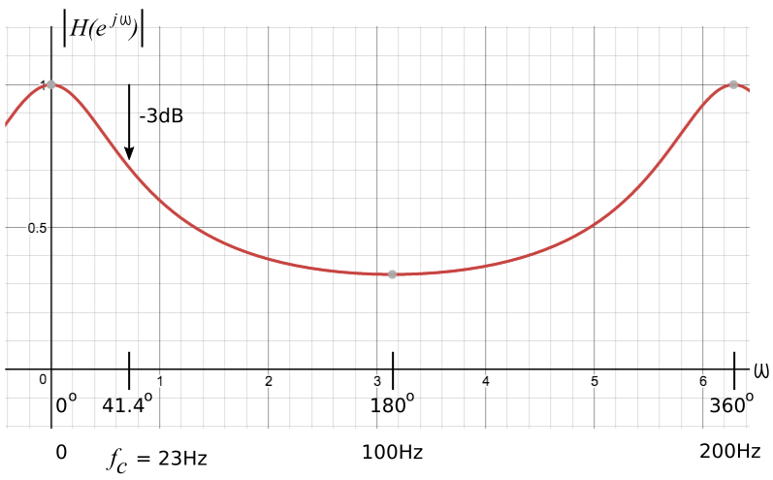
The magnitude of the FT is:
$\left|H\left(e^{jω}\right)\right|.=.\frac{1}{\sqrt{{\left(2−cosω\right)}^{2}+\sin^{2}ω}}$.
To find the 3-dB cutoff frequency, let
$\frac{1}{\sqrt{{\left(2−cosω\right)}^{2}+\sin^{2}ω}}.=.\frac{1}{\sqrt{2}}$.
$4−4cosω+\cos^{2}ω+\sin^{2}ω.=.2$ ⇒
$3−4cosω=.0$ ⇒
$ω_{c}.=.\cos^{−1}\frac{3}{4}.=.0.7227$radians/s =
${41.4}^{o}$ /s.
For a sampling rate of 200 Hz, this corresponds to $f_{c}=23$Hz.
Compared to the 2nd-order FIR low-pass filter that has a cutoff frequency of 36 Hz, this filter has a lower cutoff frequency and a fast roll-off. However, unlike the FIR filters that have linear phase, this FIR filter has a nonlinear phase and may introduce phase distortion.

Example 5. The above filter has a gain on 1/3 at the Nyquist frequency, which is half the sampling rate or at $ω=π$. Redesign the filter such that the gain is 0 at $ω=π$ .

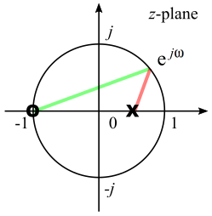
The filter design can be done with the pole-zero plot. If the zero from the previous example is moved to -1, the gain should be brought down to 0 at $ω=π$ without any significant changes on other properties of the filter.
The new pole-zero plot is shown on the right.
The transfer function is
$$H\left(z\right).=.\frac{Y\left(z\right)}{X\left(z\right)}.=.\frac{1}{4}\left(\frac{z+1}{z−\frac{1}{2}}\right).=.\frac{z+1}{4z−2}.=.\frac{1}{4}\left(\frac{1+z^{−1}}{1−\frac{1}{2}z^{−1}}\right)$$
$Y\left(z\right)\left(4−2z^{−1}\right).=.X\left(z\right)\left(1+z^{−1}\right)$ ⇒ $Y\left(z\right).=.\frac{1}{4}\left(X\left(z\right)+z^{−1}X\left(z\right)+2z^{−1}Y\left(z\right)\right)$.
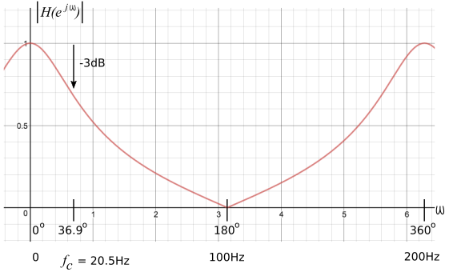
The filter equation in the time domain is:
$y\left[n\right].=.\frac{1}{4}\left(x\left[n\right]+x\left[n−1\right]+2y\left[n−1\right]\right)$.
The FT is:
$H\left(e^{jω}\right).=.\frac{1}{2}\left(\frac{1+e^{−jω}}{2−e^{−jω}}\right)$.
The magnitude (as shown) is:
$\left|H\left(e^{jω}\right)\right|.=.\frac{1}{2}\frac{\sqrt{{\left(1+cosω\right)}^{2}+\sin^{2}ω}}{\sqrt{{\left(2−cosω\right)}^{2}+\sin^{2}ω}}$.
To find the 3-dB cutoff frequency, let
$\frac{1}{2}\frac{\sqrt{{\left(1+cosω\right)}^{2}+\sin^{2}ω}}{\sqrt{{\left(2−cosω\right)}^{2}+\sin^{2}ω}}.=.\frac{1}{\sqrt{2}}$ ⇒ ${\left(1+cosω\right)}^{2}+\sin^{2}ω.=.2\left({\left(2−cosω\right)}^{2}+\sin^{2}ω\right)$ ⇒
$1+2cosω+\cos^{2}ω+\sin^{2}ω.=.8−8cosω+2\cos^{2}ω+2\sin^{2}ω$ ⇒
$10cosω.=.8$ ⇒ $ω_{c}.=.\cos^{−1}\frac{4}{5}.=.0.6435$ radians/s = ${36.9}^{o}$/s.
For a sampling rate of 200 Hz, this corresponds to $f_{c}=20.5$Hz.

Example 6. A 60-Hz notch filter is commonly used for removing the 60-Hz line noise from the signal. Design a FIR 60-Hz notch filter.

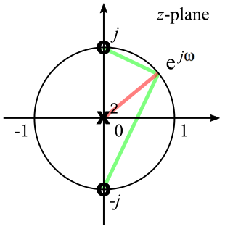
The filter design can be done with the help of the pole-zero plot. If the sampling rate is set at 240 Hz, π corresponds to 120 Hz and π/2 corresponds to 60 Hz. Thus, a zero placed at π/2 will sink the 60 Hz noise. Another zero needs to be placed at -π/2 in order to ensure that the coefficients of the filter equation are real number. Thus, we have a second-order system. The two poles are placed at the origin such that the filter is a FIR filter.
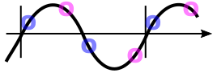
The transfer function is: $H\left(z\right).=.\frac{1}{2}\left(\frac{\left(z−j\right)\left(z+j\right)}{{\left(z−0\right)}^{2}}\right).=.\frac{1}{2}\left(1+z^{−2}\right)$.
$2Y\left(z\right).=.X\left(z\right)+z^{−2}X\left(z\right)$ ⇒ $Y\left(z\right).=.\frac{1}{2}\left[X\left(z\right)+z^{−2}X\left(z\right)\right]$
Filter equation: $y\left[n\right].=.\frac{1}{2}\left(x\left[n\right]+x\left[n−2\right]\right)$; Impulse response: $h\left[n\right].=.\frac{1}{2}\left(δ\left[n\right]+δ\left[n−2\right]\right)$.
For a sampling rate of 240Hz, there are 4 sample points on a 60 Hz sinusoidal wave. Every other point has the opposite sign as shown. Thus, the averaging removes the 60 Hz wave .
The FT is: $H\left(e^{jω}\right).=.\frac{1+e^{−2jω}}{2}.=.e^{−jω}\left(\frac{e^{jω}+e^{−jω}}{2}\right).=.e^{−jω}cosω$
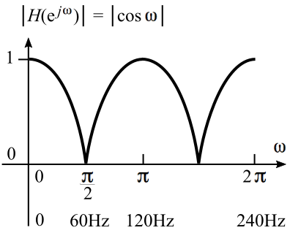
The magnitude is: $\left|H\left(e^{jω}\right)\right|.=.\left|cosω\right|$, as shown.

Example 7. Combine the 60-Hz notch filter (example 6) with the 3-pint low-pass filter (example 2) with a cascade configuration.

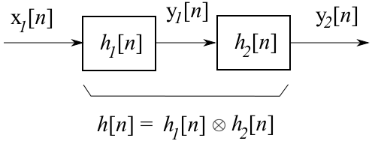
When two LTI systems are connected in cascade. The overall impulse response if the convolution of the two individual impulse responses.
As shown in the figure, $y_{1}\left[n\right]=x_{1}\left[n\right]aah_{1}\left[n\right]$ and
$y_{2}\left[n\right]=y_{1}\left[n\right]aah_{2}\left[n\right]$.
Combining the two, we have
$y_{2}\left[n\right]=\left(x_{1}\left[n\right]aah_{1}\left[n\right]\right)aah_{2}\left[n\right]$. Because the
convolution satisfies the associative property, we have
$y_{2}\left[n\right]=x_{1}\left[n\right]aa\left(h_{1}\left[n\right]aah_{2}\left[n\right]\right)=x_{1}\left[n\right]aah\left[n\right]$.
Thus, $h\left[n\right]=h_{1}\left[n\right]aah_{2}\left[n\right]$.
Low-pass filter: $h_{1}\left[n\right].=.\frac{1}{4}\left(δ\left[n\right]+2δ\left[n−1\right]+δ\left[n−2\right]\right)$
60 Hz notch filter: $h_{2}\left[n\right].=.\frac{1}{2}\left(δ\left[n\right]+δ\left[n−2\right]\right)$
Combined: $h_{1}\left[n\right].=.\frac{1}{8}\left(δ\left[n\right]+2δ\left[n−1\right]+δ\left[n−2\right]+δ\left[n−2\right]+2δ\left[n−3\right]+δ\left[4\right]\right).=.$
$$\frac{1}{8}\left(δ\left[n\right]+2δ\left[n−1\right]+2δ\left[n−2\right]+2δ\left[n−3\right]+δ\left[n−4\right]\right)$$
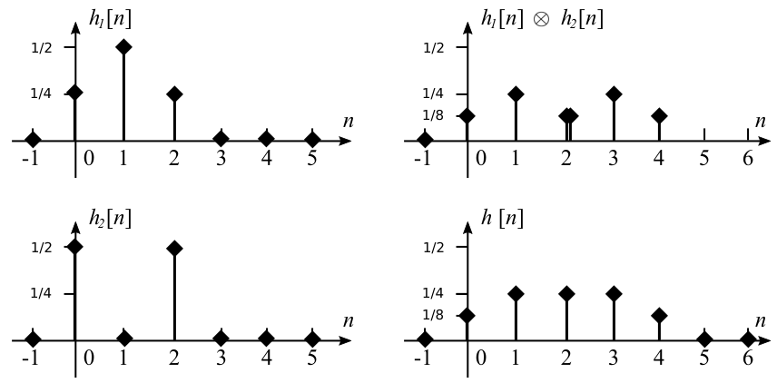
Figure on the right shows how this can be done graphically.

Because convolution in the time domain is equivalent to multiplication in the frequency domain, the overall transfer function is the product of the individual transfer functions.
$H\left[z\right].=.\frac{1}{4}\left[1+2z^{−1}+z^{−2}\right]\frac{1}{2}\left[1+z^{−2}\right].=.\frac{1}{8}\left[1+2z^{−1}+2z^{−2}+2z^{−3}+z^{−4}\right]$.
The filter equation is: $y\left[n\right].=.\frac{1}{8}\left(x\left[n\right]+2x\left[n−1\right]+2x\left[n−2\right]+2x\left[n−3\right]+x\left[n−4\right]\right)$.
The FT is: $H\left(e^{jω}\right).=.\left(e^{−jω}cosω\right)\left(\frac{e^{−jω}}{2}\left(1+cosω\right)\right).=.e^{−2jω}\frac{\left(cosω\right)\left(1+cosω\right)}{2}$.
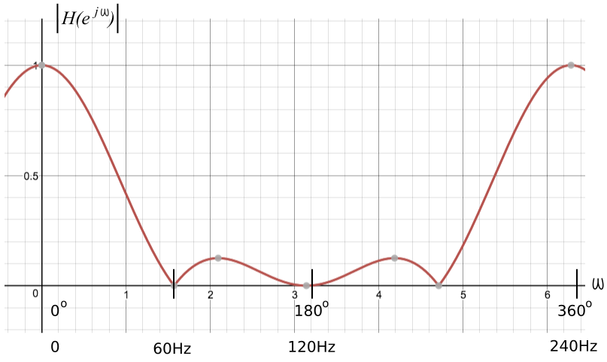
The magnitude of $H\left(e^{jω}\right)$ is given by:
$\left|H\left(e^{jω}\right)\right|.=.\left|\frac{\left(cosω\right)\left(1+cosω\right)}{2}\right|$.

Example 8. Analyze the following filter: $y\left[n\right].=.x\left[n\right]−x\left[n−1\right]+\frac{1}{4}y\left[n−2\right]$.

Transfer function: Take ZT, we have
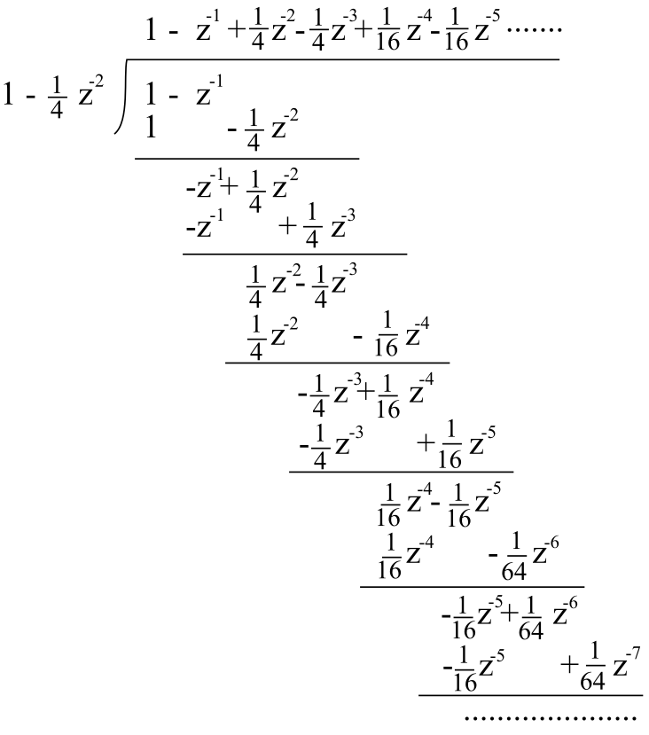
$Y\left(z\right).=.X\left(z\right)−z^{−1}X\left(z\right)+\frac{1}{4}z^{−2}Y\left(z\right)$⇒ $H\left(z\right)=\frac{Y\left(z\right)}{X\left(z\right)}.=.\frac{1−z^{−1}}{1−\frac{1}{4}z^{−2}}.=.\frac{1−z^{−1}}{\left(1−\frac{1}{2}z^{−1}\right)\left(1+\frac{1}{2}z^{−1}\right)}$.
Impulse response: Impulse response can be obtained by solving the recursion or by doing a long division as shown. From the long division, we have
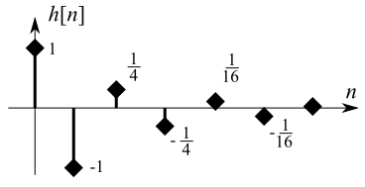
$$h\left[n\right].=.\left\{\begin{aligned}{\left(\frac{1}{4}\right)}^{\frac{n}{2}}aaaan:even \\ −{\left(\frac{1}{4}\right)}^{\frac{n−1}{2}}aan:odd\end{aligned}\right.$$

Frequency response: Obtain the FT by substituting $z=e^{jω}$. We have
$$H\left(e^{jω}\right).=.\frac{1−e^{−jω}}{1−\frac{1}{4}e^{−2jω}}.=.\frac{2je^{\frac{−jω}{2}}\left(\frac{e^{jω}−e^{−jω}}{2j}\right)}{\frac{3}{4}+\frac{1}{2}je^{−jω}\left(\frac{e^{jω}−e^{−jω}}{2j}\right)}.=.\frac{je^{−jω}sin\left(\frac{ω}{2}\right)}{\frac{3}{2}+je^{−jω}sinω}$$
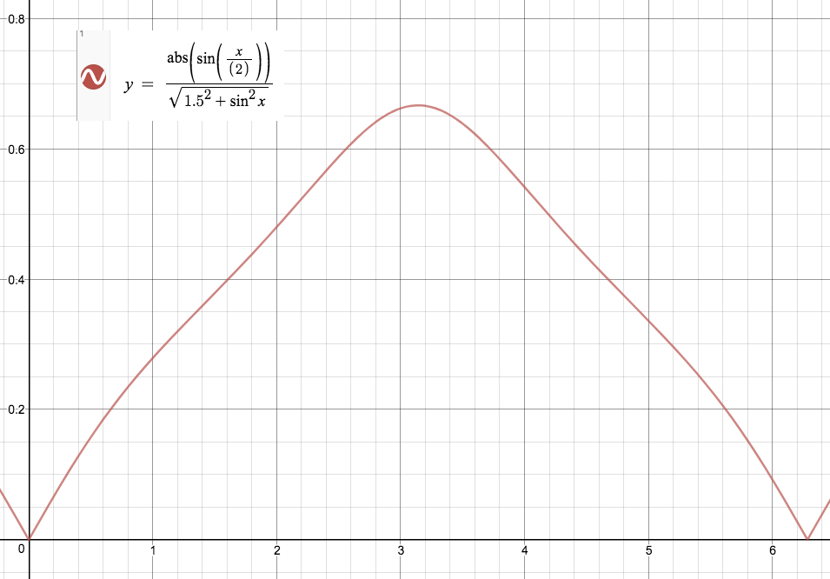
$\left|H\left(e^{jω}\right)\right|.=.\frac{\left|sin\left(\frac{ω}{2}\right)\right|}{\sqrt{{\left(\frac{3}{2}\right)}^{2}+\sin^{2}ω}}$, which is plotted on the right using the online graphing calculator at <www.desmos.com/calculator>.

Pole-zero plot: The transfer function can be written as:
$$H\left(z\right).=.\frac{1−z^{−1}}{\left(1−\frac{1}{2}z^{−1}\right)\left(1+\frac{1}{2}z^{−1}\right)}.=.$$
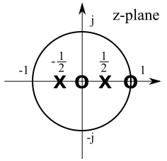
$$\frac{\left(z−0\right)\left(z−1\right)}{\left(z−\frac{1}{2}\right)\left(z+\frac{1}{2}\right)}$$
The system has two poles and two zeros at:
Poles: $\frac{1}{2}$, $−\frac{1}{2}$
Zeros: 0, 1
The pole-zero plot is shown on the right.

