Z-Transform and Digital Systems
Ying Sun

Digital systems
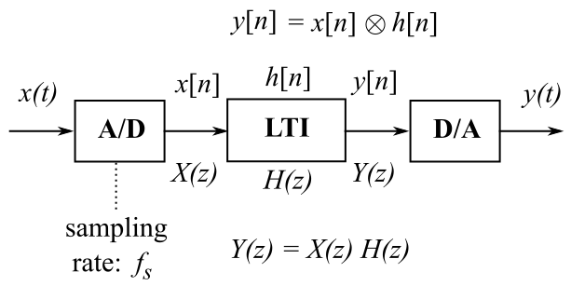
Figure on the right shows a typical discrete-time system for processing real-world (analog) signals. The analog input x(t) is digitized by the analog-to-digital converter (A/D). The resulting digital input x[n] is sent to a digital linear time-invariant system (LTI) for processing. The output digital signal y[n] is sent to the digital-to-analog converter (D/A), which generates the analog output y(t).

The sampling rate$f_{s}$ set forth by the A/D is arguably the most crucial parameter in this digital system. Sampling is almost always done periodically with a sampling period of T.
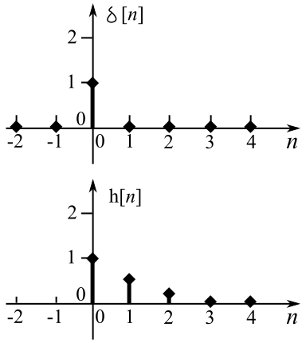
$f_{s}=\frac{1}{T}$
The digital (or discrete-time) signal is a sequence of numbers. The actual time axis should be denoted as … -3T, -2T, -T, 0, T, 2T, 3T, …, where T is the sampling period. Without losing generality we drop T and just use the index n to represent the time axis. As shown in the figure, The impulse is the delta function that takes the value of 1 at n = 0, and 0 elsewhere. The output in response to the Kronecker δ[n] is the impulse response h[n]. The impulse response h[n] completely characterizes a discrete-time LTI system, because the output is the convolution of the input and the impulse response:
$y\left[n\right].=.x\left[n\right]aah\left[n\right]$
$y\left[n\right].=.\sum_{m=−∞}^{∞}{x}\left[m\right]h\left[n−m\right].=.\sum_{m=−∞}^{∞}{x}\left[n−m\right]h\left[m\right]$
The digital equivalence to the Laplace transform (LT) is the z-transform. The z-transform (ZT) and the inverse z-transform (IZT) are defined as follows:
ZT: $X\left(z\right)=\sum_{n=−∞}^{∞}{x}\left[n\right]z^{−n}$
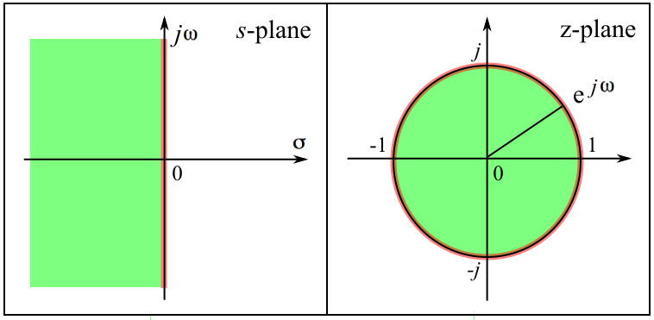
IZT: $x\left[n\right]=\frac{1}{2πj}\oint{X}\left(z\right)z^{n−1}dz$
where $z=re^{jω},a\left|\sum_{−∞}^{∞}{x}\left[n\right]z^{−n}\right|<∞$
The relationship between LT and ZT is illustrated in the figure. The jω axis on the s-plane is mapped onto the unit circle $e^{jω}$on the z-plane. The left-hand-side of the s-plane is mapped onto the inside of the unit circle.
The Fourier transform is the ZT evaluated on the unit circle. The Fourier transform (FT) and the inverse Fourier transform (IFT) are defined as follows:
FT: $X\left(e^{jω}\right)=\sum_{n=−∞}^{∞}{x}\left[n\right]e^{−jωn}$
IFT: $x\left[n\right]=\frac{1}{2π}\int_{−π}^{π}{X}\left(e^{jω}\right)e^{jωn}dω$

Duality
Duality refers to certain properties of the linear transforms that exhibit symmetry between the time domain and the frequency domain.
 | Time domain | Frequency domain
Duality | Time-limited | Band-unlimited
Duality | Time-unlimited | Band-limited
Duality | Periodic | Discrete
Duality | Discrete | Periodic
A periodic signal consists of its fundamental and harmonics, but no other frequencies. Therefore, its frequency spectrum is discrete. Based on duality, a discrete signal has a periodic frequency spectrum. One way to understand this is that the discrete Fourier transform is evaluated around the unit circle. Thus, the frequency spectrum of a discrete signal has a period of 2π. This is also related to the Nyquist sampling theory, discussed in more detail below.

Sampling theory (aka Nyquist sampling theory, Nyquist-Shannon sampling theory)

A sufficient sampling frequency to represent a signal is at least higher than twice the highest frequency component of the signal. To illustrate this, consider the following example: A sine wave has frequency $f_{0}$. If we choose a sampling rate right at the Nyquist limit, which is $2f_{0}$, we get two sample points on each cycle. We could get all 0's and fail to represent the signal. However, if we sample at a rate > $f_{0}$, we will avoid the straight line scenario and can represent that frequency.
