Signal Flow Graphs of Digital Filters Ying Sun

Realization of Digital Filters
The LTI systems in the discrete time can be generalized according to the following:
$y\left[n\right].=.\sum_{k=1}^{N}{a_{k}}y\left[n−k\right]+\sum_{k=0}^{M}{b_{k}}x\left[n−k\right]$.
Without loosing generality, we can let N = M and assigning 0 to the extra coefficients $a_{k}$or $b_{k}$. Taking ZT of the filter equation, we have
$Y\left(z\right).=.Y\left(z\right)\sum_{k=1}^{N}{a_{k}}z^{−k}+X\left(z\right)\sum_{k=0}^{N}{b_{k}}z^{−k}$. The transfer function is given by.
$H\left(z\right)=\frac{Y\left(z\right)}{X\left(z\right)}.=.\frac{\sum_{k=0}^{N}{b_{k}}z^{−k}}{1−\sum_{k=1}^{N}{a_{k}}z^{−k}}$.
Direct Form 1
An realization of this system is represented by the following signal flow diagram called Direct Form 1. The validity of Direct Form 1 is obvious by comparing the filter equation and the signal flow graph.

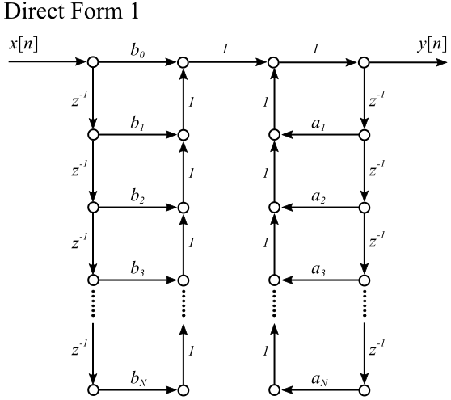
Direct Form 2
Another realization of this system, called Direct Form 2, is more efficient by using the minimum number of delays ($z^{−1}$).

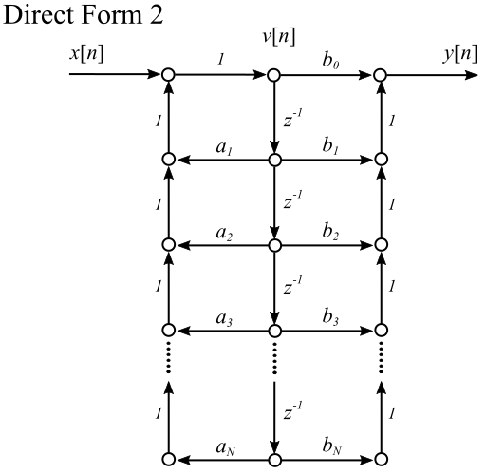
The validity of Direct Form 2 is not immediately obvious. Thus, we will prove that the Direct Form 2 does result in the same transfer function. Let v[n] be the intermediate signal as shown above.
$v_{n}.=.x\left[n\right]+\sum_{k=1}^{N}{a_{k}}v\left[n−k\right]$, and $y_{n}.=.b_{0}v\left[n\right]+\sum_{k=1}^{N}{b_{k}}v\left[n−k\right]$.
By taking the ZT of the above, we have
$V\left(z\right).=.X\left(z\right)+V\left(z\right)\sum_{k=1}^{N}{a_{k}}z^{−k}$, and $Y\left(z\right).=.b_{0}V\left(z\right)+V\left(z\right)\sum_{k=1}^{N}{b_{k}}z^{−k}$;
$V\left(z\right).=.\frac{X\left(z\right)}{1−\sum_{k=1}^{N}{a_{k}}z^{−k}}$, and $Y\left(z\right).=.V\left(z\right)\sum_{k=0}^{N}{b_{k}}z^{−k}$.
Substituting $V\left(z\right)$into $Y\left(z\right)$, we have $Y\left(z\right).=.X\left(z\right)\frac{\sum_{k=0}^{N}{b_{k}}z^{−k}}{1−\sum_{k=1}^{N}{a_{k}}z^{−k}}$. Thus, $H\left(z\right).=.\frac{\sum_{k=0}^{N}{b_{k}}z^{−k}}{1−\sum_{k=1}^{N}{a_{k}}z^{−k}}$.

Variations of Direct Form 2
The Direct Form 2 realization shown above is based on the rational form of H(z). There are two variations of Direction Form 2 based on the factored form and the partial-fraction form of H(z).

Cascade Direct Form 2
The transfer function can be arranged into the factored form, resulting in Cascade Direct Form 2 realization as shown:
$H\left(z\right)=\frac{Y\left(z\right)}{X\left(z\right)}.=.\frac{\sum_{k=0}^{N}{b_{k}}z^{−k}}{1−\sum_{k=1}^{N}{a_{k}}z^{−k}}.=.b_{0}\prod_{k=1}^{\left\lceil \frac{N+1}{2}\right\rceil }{\frac{1+β_{1k}z^{−1}+β_{2k}z^{−2}}{1−α_{1k}z^{−1}−α_{2k}z^{−2}}}$.

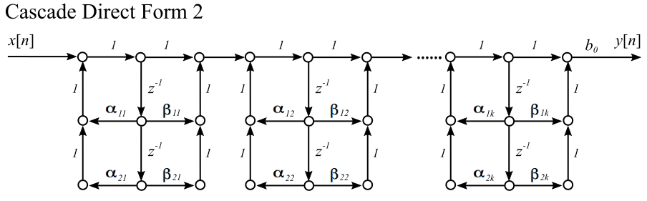

Parallel Direct Form 2
The transfer function can be arranged into the partial-fraction form, resulting in Parallel Direct Form 2 realization as shown:
$H\left(z\right)=\frac{Y\left(z\right)}{X\left(z\right)}.=.\frac{\sum_{k=0}^{N}{b_{k}}z^{−k}}{1−\sum_{k=1}^{N}{a_{k}}z^{−k}}.=.\sum_{j}{γ_{j}}z^{−j}+\sum_{k}{\frac{δ_{0k}+δ_{1k}z^{−1}}{1−ϵ_{1k}z^{−1}−ϵ_{2K}z^{−2}}}$.

